 

Universität Duisburg-Essen · Campus Duisburg

Fakultät für Ingenieurwissenschaften

Abteilung Maschinenbau

Lehrstuhl für Mechatronik

Masterarbeit

zur Erlangung des Grades eines

**Master of Science Computer Engineering**

Thema: **Prozedurale Generierung von Szenariengeometrien in Unity auf Basis von OpenDRIVE-Daten**

**Procedural generation of scenario geometries in Unity based on OpenDRIVE data**

vorgelegt von: **Rui Sun**

geb. am 08.05.1993 in China

Matrikel-Nr.: 3057943

Erstgutachter: **Prof. Dr.-Ing. Dieter Schramm**

Zweitgutachter: **Dr.-Ing. Niko Maas**

Betreuer: **Dipl.-Ing. Stephan Schweig**

Duisburg, 28.06.2019

Contents

Contents II

List of Figures III

Abstract 1

1 Introduction 2

1.1 Motivation 2

1.2 Objective Of The Work 3

1.3 Structure Of The Work 3

2 Tool Introduction 4

2.1 OpenDRIVE 4

2.2 Unity3D 5

2.3 C# 5

3 Data Introduction And Structure Establish 6

3.1 OpenDRIVE Format Data Introduction 6

3.2 Establish Predefine Data Structure 21

4 Road And Texture Generation 24

4.1 Road Generation 24

4.2 Combine Program Structure 45

4.2 Texture Generation 49

4.2.1 Texture Introduction 49

4.2.2 Draw Texture 50

4.3 Junction Problem 56

5 Results And Discussion 61

5.1 Results 61

5.2 Discussion 61

5.3 Outlook 62

Bibliography 65

Appendix 66

List of Figures

Figure 2.1 simulation tool-chain [3] 4

Figure 3.1 OpenDRIVE Data Structure 7

Figure 3.2: Coordinate Systems [3] 8

Figure 3.3: Track Coordinate System 1 [3] 9

Figure 3.4: Track Coordinate System 2 [3] 9

Figure 3.5: Geometry Node 10

Figure 3.6: Geometry Line 11

Figure 3.7: Geometry Spiral 12

Figure 3.8: Geometry Arc 13

Figure 3.9: Geometry Poly3 14

Figure 3.10: Geometry Parampoly3 15

Figure 3.11: Reference Line [2] 16

Figure 3.12: Geometry Lines [2] 17

Figure 3.13: Elevation 18

Figure 3.14: Chord Line [3] 19

Figure 3.15: Lanesection [2] 20

Figure 3.16: Predefine Data Structure 22

Figure 4.1: Analysis Geometry Line 25

Figure 4.2: Congruent Relationship 26

Figure 4.3: Analysis Geometry Arc 27

Figure 4.4: Analysis Geometry Spiral 30

Figure 4.5: Calculate Geometry Spiral 32

Figure 4.6: Roate Geometry Spiral 34

Figure 4.7: Analysis parameter poly 36

Figure 4.8: Analysis Elevation 38

Figure 4.9: Max Width 39

Figure 4.10: Signal Position 41

Figure 4.11: Right Direction 42

Figure 4.12: Right Direction 42

Figure 4.13: Wrong Direction 43

Figure 4.14: Road Mesh Triangulation Case 44

Figure 4.15: Road Mesh In Unity3D 44

Figure 4.16: Program Flow Chart 45

Figure 4.17: Function Diagram 46

Figure 4.18: Road Network 1 47

Figure 4.19: Road Network 2 47

Figure 4.20: Road Network 3 48

Figure 4.21: Texture 49

Figure 4.22: LaneOffset [2] 50

Figure 4.23: Lane Texture 51

Figure 4.24: Program Flow Chart 53

Figure 4.25: Road Network With Texture 1 54

Figure 4.26 road network with texture 2 54

Figure 4.27: Road Network With Texture 3 55

Figure 4.28 Flicker Crossing 1 56

Figure 4.29 Flicker Crossing 2 57

Figure 4.30 Layers Overlap 57

Figure 4.31 Change Layer Height 58

Figure 4.32 Layer Transparent 58

Figure 4.33 Gab Problem 59

Figure 4.34 Convex Hull 60

Figure 4.35 Junction Layer 60

Figure 5.1: Dynamic Width 62

Figure 5.1 Delaunay Triangulation 64

Figure A.1: Sample Of Dead-end Road 66

Figure A.2: Sample Of a Atandard Crossing With Traffic Lights 67

Figure A.3: Sample Of a Standard Crossing With Traffic Lights 67

Figure A.4: Sample Of a Roundabout 68

Figure A.5: Sample Of a Roundabout 68

Figure A.6: Sample Of a Complex Crossing With Traffic Lights 69

Figure A.7: Sample Of a Complex Crossing With Traffic Lights 69

Figure A.8: Sample By Atlatec 70

Figure A.9: Sample By Atlatec 70

Figure A.10: Sample By Chair Of Mechatronics 71

Figure A.11: Sample By Chair Of Mechatronics 71

Abstract

The driving simulation is becoming more and more important in the automotive field. A road network model is the basis of driving simulation. So there is a requirement to establish road network model which map the real road network. The traditional method is to create a road network model manually. But this way costs to much time and has high possibility to make the error. There are some companies offer some paid software though work well paid too much.

The goal of this thesis is to produce a plugin, which can generate geometrical road and relevant objects e.g. signals, lane and elevation automatically, precisely, quickly and free according to OpenDRIVE which is an open file format describing physical properties of individual roads and road networks for driving simulation applications using Unity3D which is a game engine which can also be used as a simulator.

Keywords: driving simulator, geometrical road generation, OpenDRIVE, Unity3D

1 Introduction

In this chapter, there are three parts. First part is motivation, it introduces the background of the thesis and gives the reasons why develop the plugin is needed. The second part is objective of the work, it lists some features which the plugin should have according to the requirements. The third part is the structure of the work, it gives three steps about how the plugin be developed gradually.

1.1 Motivation

There are many ways to give a logical description of a road network and road objects. For example, if you want to describe a straight road segment, simply assume it as a straight line segment. Things become in a three-dimension coordinate system, determine a line segment. You can determine a line by start coordinate, and end coordinate or start coordinate, direction vector, and the length of the line. So there are several standardized formats developed to logical description of the road network and road objects. One main format is OpenDRIVE, which has been developed by numerous companies under the direction of VIRES. Some companies provided their own commercial solution to generate road according to OpenDRIVE. But the way to implement still not too clearly and not under an open source lisence. So there is a requirement to analysis OpenDRIVE data format and visualization data to generate roads.

1.2 Objective Of The Work

This thesis work will be focusing on the development of a plugin which can read OpenDRIVE format data and transfer it into a predefined data structure and visualization the data in a simulation environment based on Unity3D. The OpenDRIVE already includes describing physical properties such as the length of the road, elevation of individual roads and road networks, but it is in specific XML format, and it is difficult to fast read and interpret by a simulator, so it is necessary to interpret OpenDRIVE format data into a specific pattern that is better recognized by the simulator firstly.

The plugin should have the following features：

* Easy to operate
* Efficient
* At least visualization road structure, lane, elevation, signals, and crossing.
* Low code complexity

1.3 Structure Of The Work

Developing the plugin require three main steps. The first step, analysis the tools which relevant the goal of the thesis and decide which tools to use. The second step, understand OpenDRIVE format data which is a kind of structured data which can be used to describe logic road network and according to the structure of data to establish predefine data structure and load the OpenDRIVE format data in it. The third step, read the data in the predefined structure, analysis, and create road network model to visualization the data in Unity3D which is a kind of engine and can be used to a driving simulator.

2 Tool Introduction

In this chapter, the tools used to develop the plugin will be introduced and give some reasons about why use these tools.

2.1 OpenDRIVE

OpenDRIVE is a file format including data which has a structure which can use to logical description road networks [1].

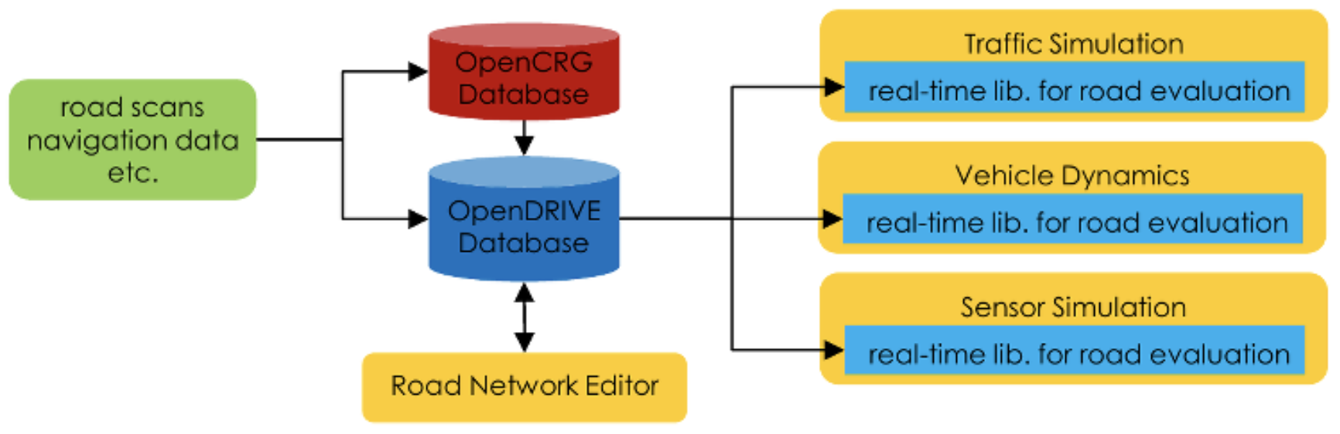

Figure 2.1 simulation tool-chain [3]

As the figure 2.1 show, mostly the OpenDRIVE database is produced by road scans or navigation data, and then the OpenDRIVE database will be used to e.g. vehicle dynamics, traffic simulation and sensor simulation [1]. The goal of the plugin is to visualization the OpenDRIVE database to work for other branches. OpenDRIVE file format uses a hierarchical structure which is established by XML nodes, to store the features that can describe the logic of road network.

The OpenDRIVE format data contains all important features of real road networks, as wants to create a road network model for driving simulation. The standard of data format has been accepted by board international users and has numerous successful use cases.

2.2 Unity3D

Unity3D is a popular cross-platform game engine [4]. Users can use Unity3D create game and model easily as it has a user-friendly development environment.

As the requirement of the plugin is to create road networks according to OpenDRIVE format data and use the road network model to do driving simulation. Unity3D support script to create both two-dimensional and three‑dimensional model, with the help of a script, can visualization OpenDRIVE format data quickly and accurately. As Unity3D is a game engine, it certainly supports driving simulation.

2.3 C#

C# is an object-oriented programming language developed by Microsoft. It has all the advantage features which other object-oriented programming languages have.

The main reason for using C# is that now Unity3D only supports C# as its scripting language, as want to use the script to analysis OpenDRIVE format data and visualization it in Unity3D.

3 Data Introduction And Structure Establish

In this chapter, will introduce OpenDRIVE format data, and establish a predefined data structure to store the data in order to simulator easy to read data and efficient to generate geometry road.

3.1 OpenDRIVE Format Data Introduction

The OpenDRIVE format data is based on road nodes as a unit. An OpenDRIVE format data may include thousands of road node (figure 3.1a). Each road node describes a road section and includes all important record (e.g. length of the road, elevation of the road, the number of the lane in the road section (figure 3.1b) that can describe the geometry and logic of the road section.

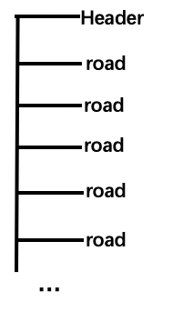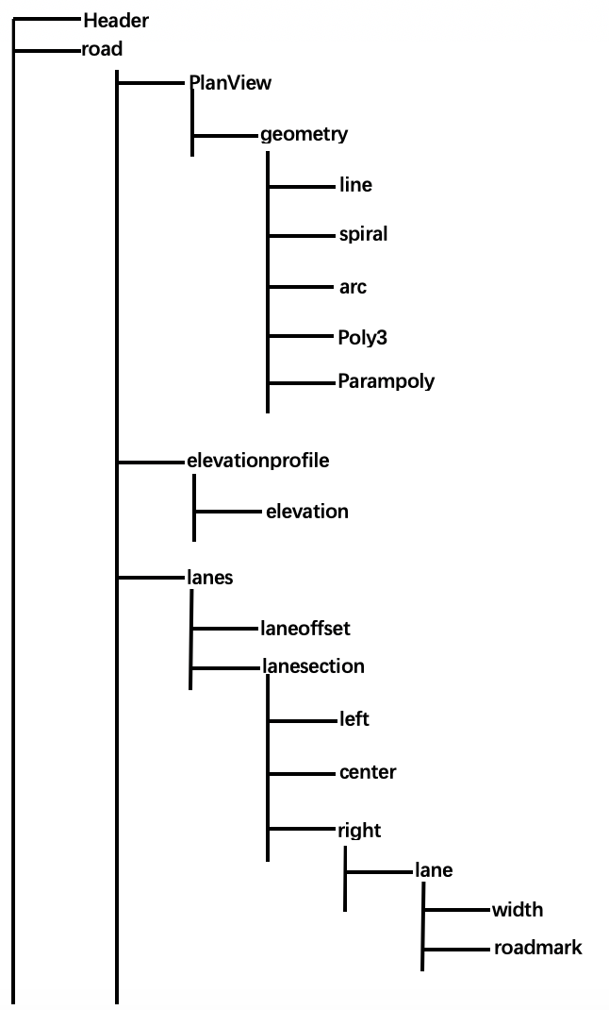

(a) (b)

Figure 3.1 OpenDRIVE Data Structure

Before explaining the node record, firstly should know two coordinate systems. Track coordinate system and inertial coordinate system are most frequently used in OpenDRIVE file.

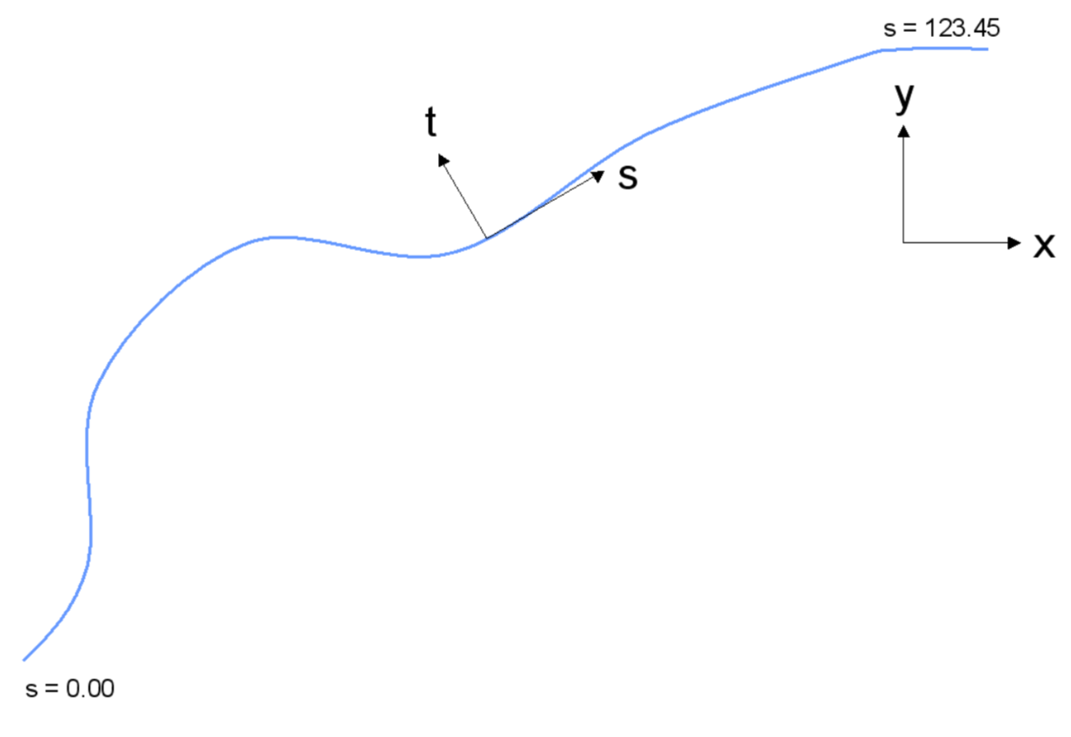

Figure 3.2: Coordinate Systems [3]

Figure 3.2 shows the two coordinate systems used. Each coordinate system in its dimension to describe the position vector. In the inertial system, assume the road track as a line track, vector (*x, y*) belongs to the inertial system. The track coordinate system applies along the line track. Vector (*t, s*) belong to track coordinate system [3]. You can consider an inertial system as a world coordinate system. Direction *x* means forward, direction *y* means left, direction *z* means up [3]. If you decide a position vector *(x, y, z)*, you can only decide on point in the inertial system. Points decide line, lines decide flat, so if you decide hundreds of thousands of points, you will decide any geometry road. For convenient, all geometry coordinate is based on the internal system.

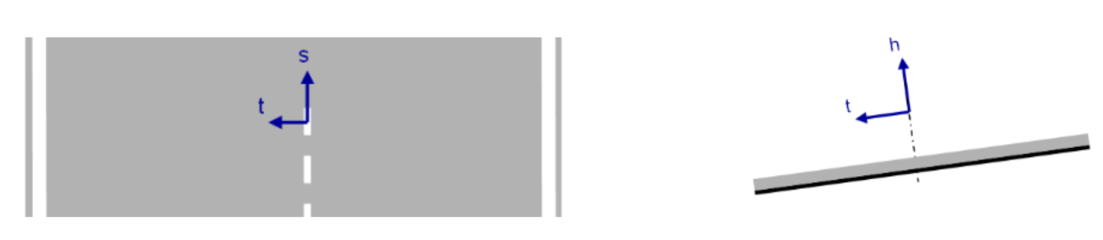

(a) (b)

Figure 3.3: Track Coordinate System 1 [3]

According to the Format Specification, Rev. 1.5 [3], direction *s* means position along the road track, measured in [m] from the beginning of the track, calculated in the *XY*-plane (inertial coordinate system). Direction *t* means lateral position, left is positive. Direction *h* means up. The track coordinate system is most used to describe the logic of the road. For example, you can describe a new lane line use two point *A* and *B* as shown in figure 3.4 compare to figure 3.3a.

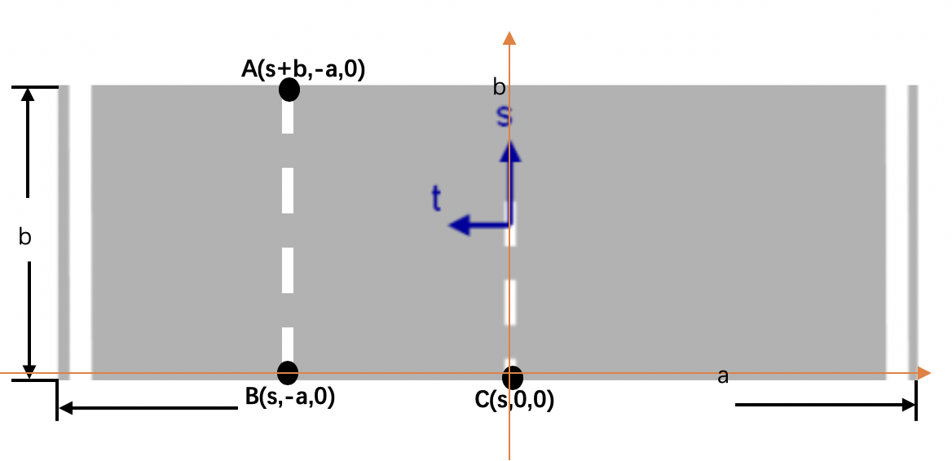

Figure 3.4: Track Coordinate System 2 [3]

After use the OpenDRIVE format data successfully to generate a road network, it is not necessary (according to the goal of the thesis) to use all the record in each road node, in the following, some necessary record will be introduced according to the Format Specification, Rev. 1.5 [3], and how to use the record to generate road sections.

The top element of a road description is called “road”. The road tag represents a road section and is the unit of the road network, road network may consist of hundreds of thousands of roads section. Each road section includes the describe record of the geometry and logic of the road section. It is mainly used to create the geometry of the road network.

The planView tag is located below the road node and contains a series of geometry node records which define the layout of the road's chord line in the x/y-plane.

The geometry tag can be found below the planeView node. It represents a geometric segment and contains the most important data (position, rotation and length). There are five kinds of subnodes in geometry node, line node, spiral node, arc node, poly3 node, and parampoly3 node.

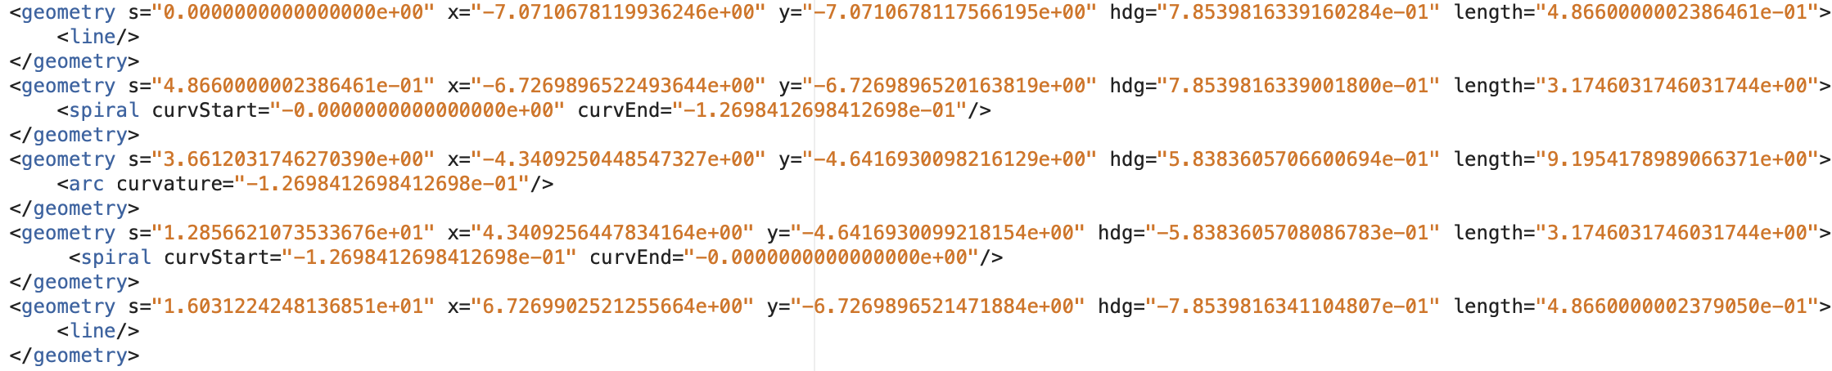

Figure 3.5: Geometry Node

Figure 3.5 shown three typical subnodes, line node, arc node and spiral node. Each kind of node can describe a specific geometry curve, different geometries are connected end to end to form a geometric chord line. In file Format Specification, Rev.1.5 [3] the chord line is named road reference line.

The geometry node has five attributes – *s, x, y, hdg* and *length*. *S* is the absolute position (track coordinate system) in its road section, *x/y* is the coordinate of the point in intertial system, *hdg* is heading angle of the direction (intertial system) of the following geometric curve, and *length* is the length of the curve. Below the geometry node there are nodes for the geometric description of the curve section. The tag line has no attributes, since the parameters of the superior geometry node already contain all data for a line (figure 3.6).

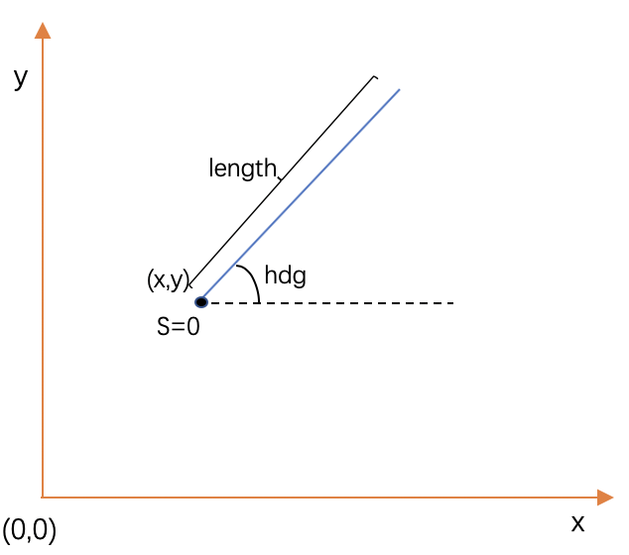

Figure 3.6: Geometry Line

In addition to the line, there is also a tag for a spiral. The spiral node has two parameters named *curvStart* and *curvEnd*. This record describes a spiral section from *curvature*=0 as part of the road reference line. For this type of spiral, the *curvature* change between the start and end of the element is linear [3]. The curvature change rate is cdot. The equation of calculating cdot is following:

$cdot= (curvEnd-curvStart)/{length}_{spiral}$ (3.1)

Figure 3.7 Show curvature change rate is 1, according to different cdot, you can draw different kinds of spiral with different curvature change rate.

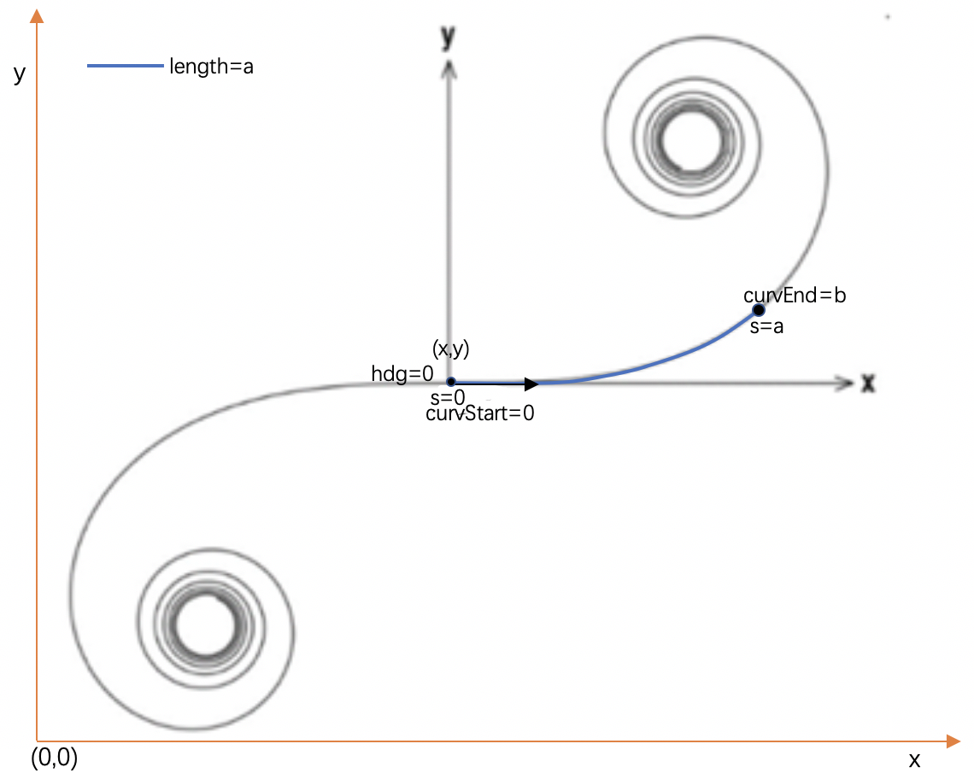

Figure 3.7: Geometry Spiral

The cdot of figure 3.7 is calculated in following equation:

$cdot=(b-0)/a=1$ (3.2)

The rules of road design provide that a spiral connects a line and an arc by a spiral. The arc tag has only one attribute. It is enough to draw an arc using parameter *curvature, s, x, y, hdg*, and *length* illustrated in figure 3.8.

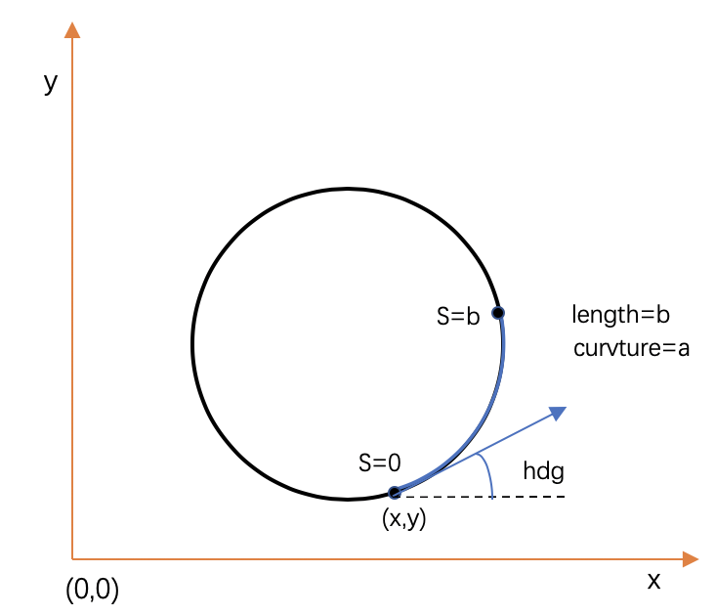

Figure 3.8: Geometry Arc

Poly3 node record describes a cubic polynomial as part of the road’s chord line.

$vlocal = a + b*du + c*{du}^{2} + d*{du}^{3}$ (3.3)

According to the equation (3.3) and the parameters poly3 node offered, you can easy to draw a geometry blue line shown in figure 3.9.

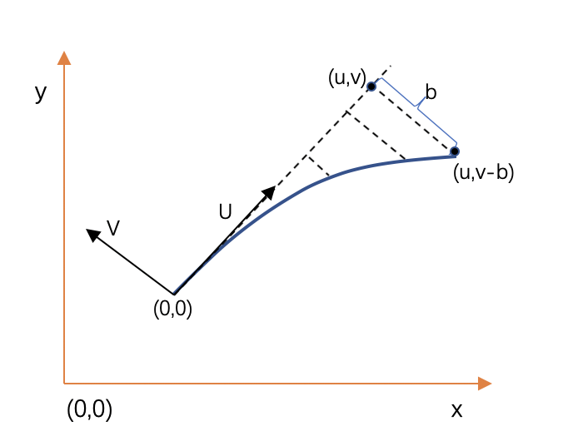

Figure 3.9: Geometry Poly3

If poly3 is not sufficient for the mapping of a desired contour, the tag parampoly3 can be used with another degree of freedom compared to poly3. Parampoly3 node record describes a parametric cubic curve as part of the road reference line.

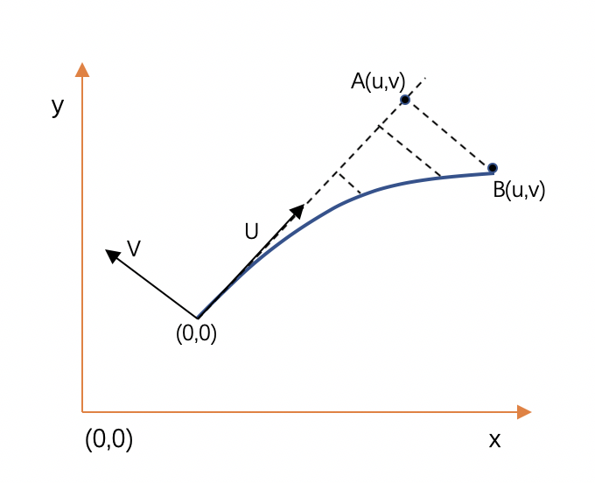

Figure 3.10: Geometry Parampoly3

$ulocal = au + bu*p + cu*p^{2}+ du*p^{3}$ (3.4)

$vlocal = av + bv*p + cv*p^{2} + dv*p^{3}$ (3.5)

According to the equation (3.4), (3.5) and the parameters Parampoly3 node offered you can easily to draw a geometry blue line shown in figure 3.10.

As figure 3.11 shown some features (b) and lanes (c) along the reference line (d) to describe a logic road (a).

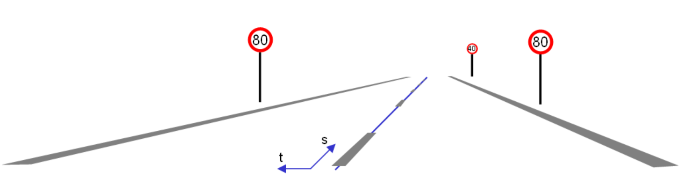

(a) logic road

(b) features

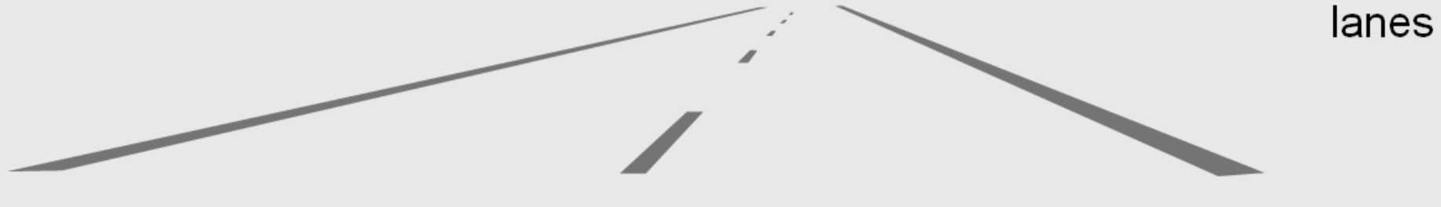(c) lanes

(d) reference line

Figure 3.11: Reference Line [2]

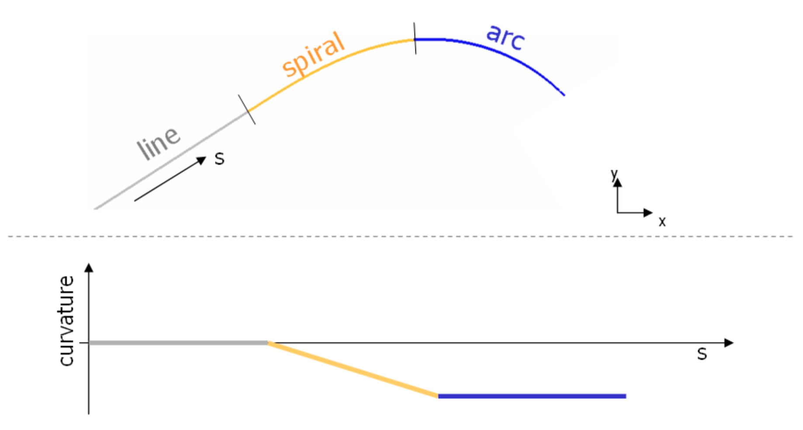

S2

S1

S0

Figure 3.12: Geometry Lines [2]

As the figure 3.12 shown, there are three kinds of geometry lines, first geometry is a line, the start position in the road section of the line is *S0*, the length of the line is *S1-S0*. The second geometry is spiral, the start of the spiral is *S1* the length is *S2-S1*, third is an arc, the start position is *S2* and the length of the arc is the length of the road section which the geometry belong to minus *S2*.

So geometry nodes describe road reference (chord) line track as figure 3.12 illustrate, laneOffset nodes according to the road reference (chord) line to describe lane reference line.

Elevation node record defines an elevation entry at a given road reference line position. Entries must be defined in increasing order along the road reference line. The parameters of entry are valid until the next entry starts or the road’s road reference line ends. Per default, the elevation of a road is zero.

The elevation is calculated by the equation:

$Elev=a+b*ds+c*{ds}^{2}+d*{ds}^{3}$ (3.6)

*ds* is the delta between the start position and the requested position.

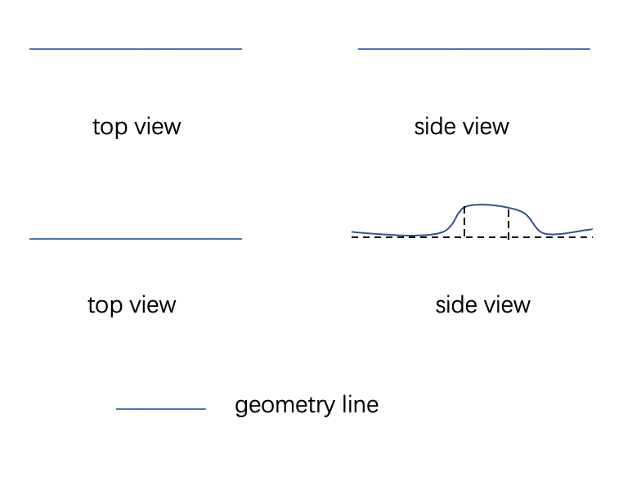

Figure 3.13: Elevation

Figure 3.13 illustrates two geometry lines. First two figure describes a line without elevation in two different views compares with the next two figure with elevation.

Lanes node belong to road node. It is consist of laneOffset and laneSection nodes and describes the lane information in the road section.

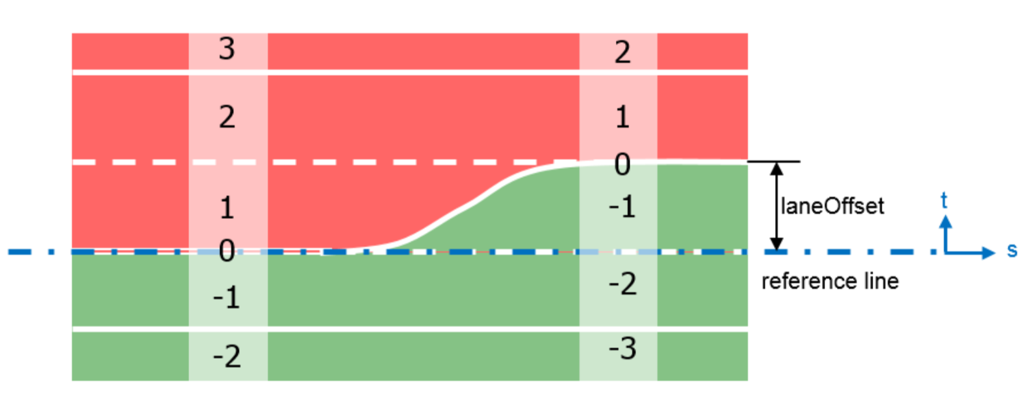

Figure 3.14: Chord Line [3]

Some time the road reference (chord) line may have offset in order to easy to implement a logic road describe. So the laneOffset node is that to describe in which s position along the road reference line has offset, the new produced line named lane reference line. In figure 3.14 shown, the number 0 line is lane reference line and the blue broken line is road reference line. When there is no laneOffset node, the road reference line is overlapped with the lane reference line and other including logic record nodes (e.g features and lanes) along the road reference (chord) line to describe a road network.

Lane section is the unit of the road section. Each road section may consist of some lanesections. The way to calculating the length of the lanesecion is similar to the geometry node.

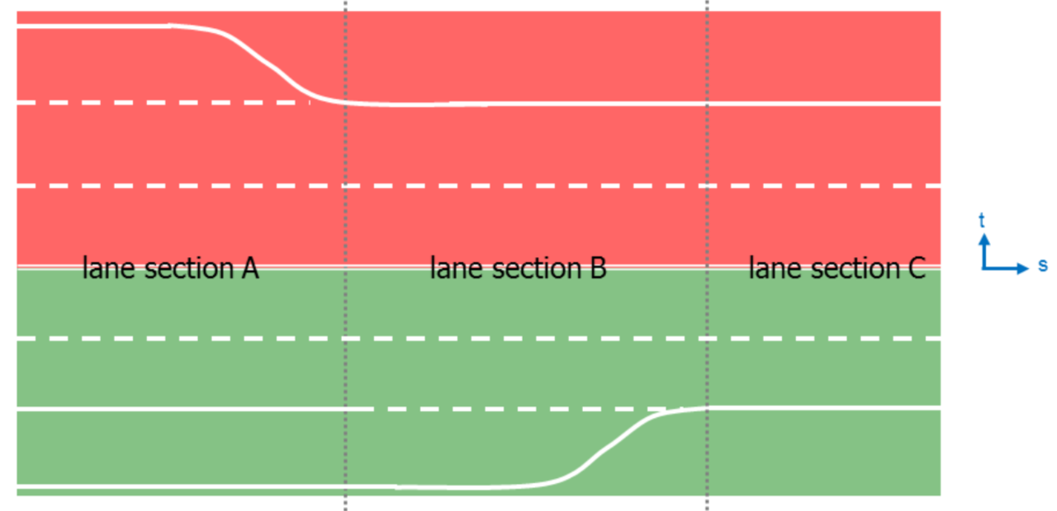

Figure 3.15: Lanesection [2]

It is convenient to describe a road section using many lanesections when the number of lanes changed along the road section. As figure 3.15 illustrates, there are three lanesection. Lane section A has 6 lanes. Lane section B has 5 lanes. Lane section C has 4 lanes.

In each laneSection node, there are three kinds of subnodes. They are the left node, center node, and right node. Each subnode has some lane node. Each lane node has a specific id in the lanesection node which lane node belongs to. as figure 3.14 illustrates, the red area with positive lane numbers described by the left node, the green area with negative lane numbers described by the right node, and the number 0 line described the center node.

In each lane node, there are some width nodes. It describes the track of the lane using formula. A new width node is required when the geometry formula is changed. The way to calculating the length of the width node is similar to the geometry node. Each width node can describe a specific geometry of the lane section. As figure 3.15 shown, there are three width nodes in lane section A red area divided by two blue broken lines. Some different width nodes can describe a complex geometry of the lane section.

roadMark node is a subnode of the lane node. It describes the type of lane border line. Each lane border line may have not only one kind of type. They may be broken, soild none or others.

As figure 3.15 shown, in the lane section B green area, there are three types of lane border line divided by the yellow broken line. The first section is soild, the second section is broken and the last section is none.

The signal record is used to provide information about signs and signals along a road and belongs to the road node. Signals are signs that can change their state dynamically (e.g.  traffic  lights). The signal record consists of the main record and an optional lane validity record.

3.2 Establish Predefine Data Structure

Each node in the OpenDRIVE format data has enough parameter to describe a specific geometry or logic relationship. So establish the following data structure to store the node record from OpenDRIVE format data.

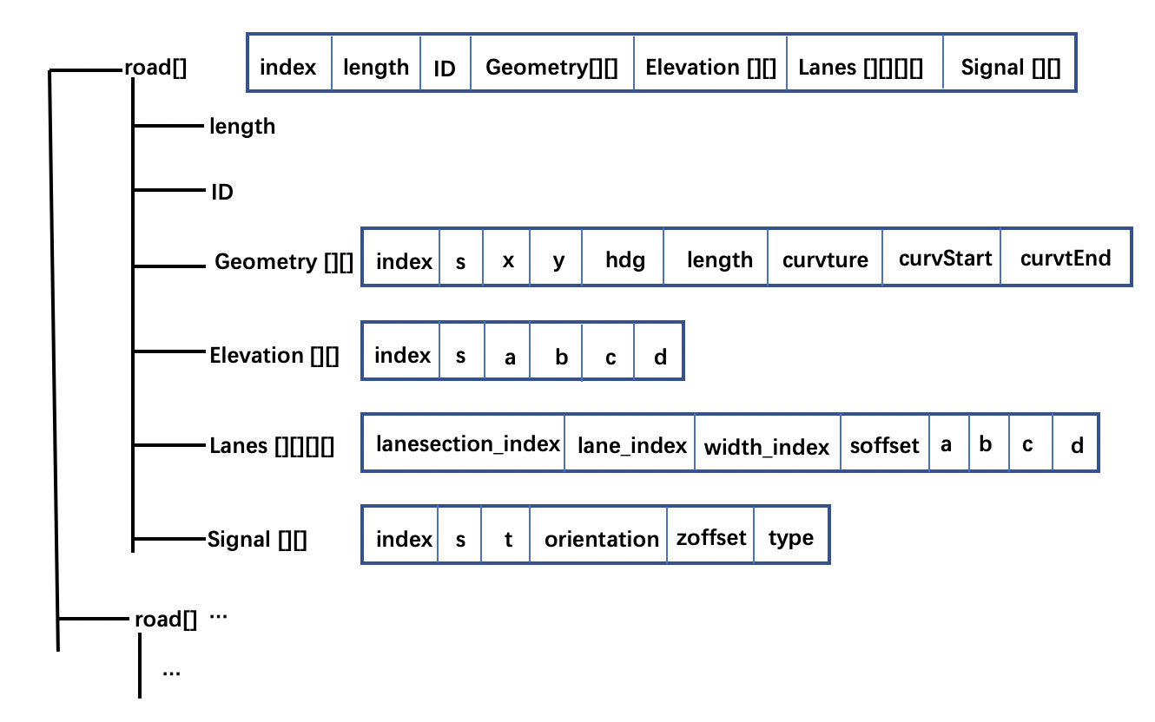

Figure 3.16: Predefine Data Structure

As the figure 3.16 illustrate, in each road node has some subnodes which can describe the geometry and logic relationship of the road section. So the outter loop is road[i] to read road node. in the inner (road) loop, there should be four array

1. geometry[index][parameter]
2. elevation[index][parameter]
3. lanes[lanesection_in­d­ex][lane_index][width_index][parameter]
4. signals[index][parameter]

to store parameters.

|  |
| --- |
| **Algorithm**: establish predefine data structure and load data from OpenDRIVE |
| 1. for *r* in *road* do 2. *road[r].length* <-read road section length 3. *road[r].id* <-read road section id 4. for *g* in *geometry* do 5. for *p* in *geometry_parameter* do 6. *geometry[g][p]* <-read parameter in geometry node 7. for *e* in *elevation* do 8. for *p* in *elevation_parameter* do 9. *elevation[e][p]* <-read parameter in elevation node 10. for *ls* in *lanesection* do 11. for *la* in *lane* do 12. for *w* in *width* do 13. for *p* in *width_parameter* do 14. *lanes[is][la][w][p]* <-read parameter in lane node 15. for *s* in *signals* do 16. for *p* in *signals_parameter* do 17. *signals[s][p]* <-read parameter in signals node 18. Return predefine data structure including data from OpenDRIVE |

4 Road And Texture Generation

Last chapter already introduced how to establish a predefined structure to store the parameter which comes from OpenDRIVE file. Using the parameter can easily to establish a road network and road texture. In this chapter, there are three parts, the first part, Road Generation, introduces how to generate the geometry track of the road and road mesh in Unity3D. Second part, Establish Road Mesh In Unity3D, introduce how to generate lane texture according to the predefined data structure in Unity3D. Third part, Junction Problem, introduce there is a flicker problem on junction after create road network and how to deal with this problem.

4.1 Road Generation

Analysis line arc spiral parameter poly and elevation node and generate road mesh in Unity3D. Unity3D scene is a world coordinate system *(x,y,z)*. You can assume the inertial system overlap the scene coordinate system. So according to the inertial system coordinate, you can only decide one specific road network in Unity3D scene. Firstly analysis geometry line.

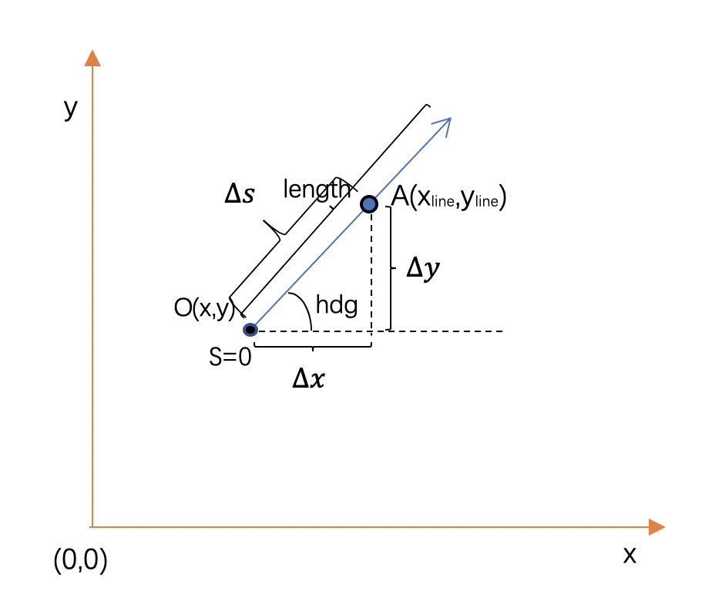

Figure 4.1: Analysis Geometry Line

As figure 4.1 illustrates, the blue point *A(xline,yline)* is a point in geometry line, it is calculated by the following equation:

$x_{line}=x+∆s*cos(hdg)$ (4.1)

$y_{line}=y+∆s*sin(hdg)$ (4.2)

Compare with figure 3.9, what is ∆s means? As the figure 4.2 illustrates, a line consists of many points which have the same spacing named ∆d which is defined by the user between each point.

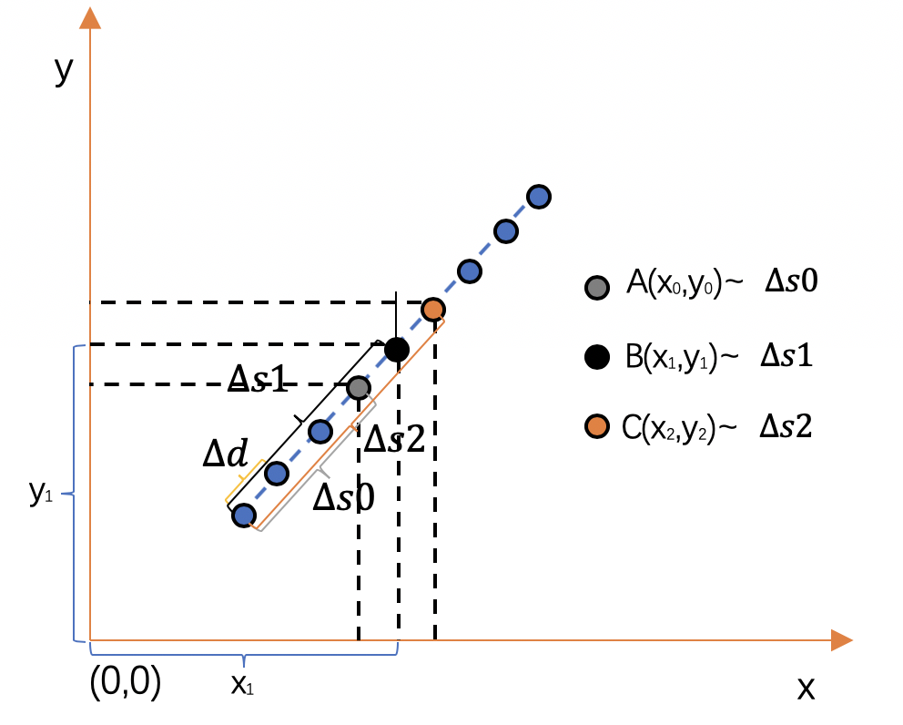

Figure 4.2: Congruent Relationship

$∆s$ consist of many $∆d$，for example $∆s0$ consists of three $∆d$ and $∆s2$ consists of five $∆d$. Each $∆s$ match specific a point in the geometry line according to trigonometric function you can calcute point belonging to the line. So repeat calculate the points you will get a line. And this way also suits for next geometry analysis.

|  |
| --- |
| **Algorithm**: calculate point set of geometry line |
| 1. for *s* in range(0,*line.length*) do step +0.1 2. *xline <- x+cos(hdg)*s* 3. *yline <- y+sin(hdg)*s* 4. Return point set of geometry line |

Secondly analysis geometry arc. According to Format Specification, Rev. 1.5 [3], the curvature is the positive when the arc is counter-clockwise motion, and negative when the arc is clockwise motion.

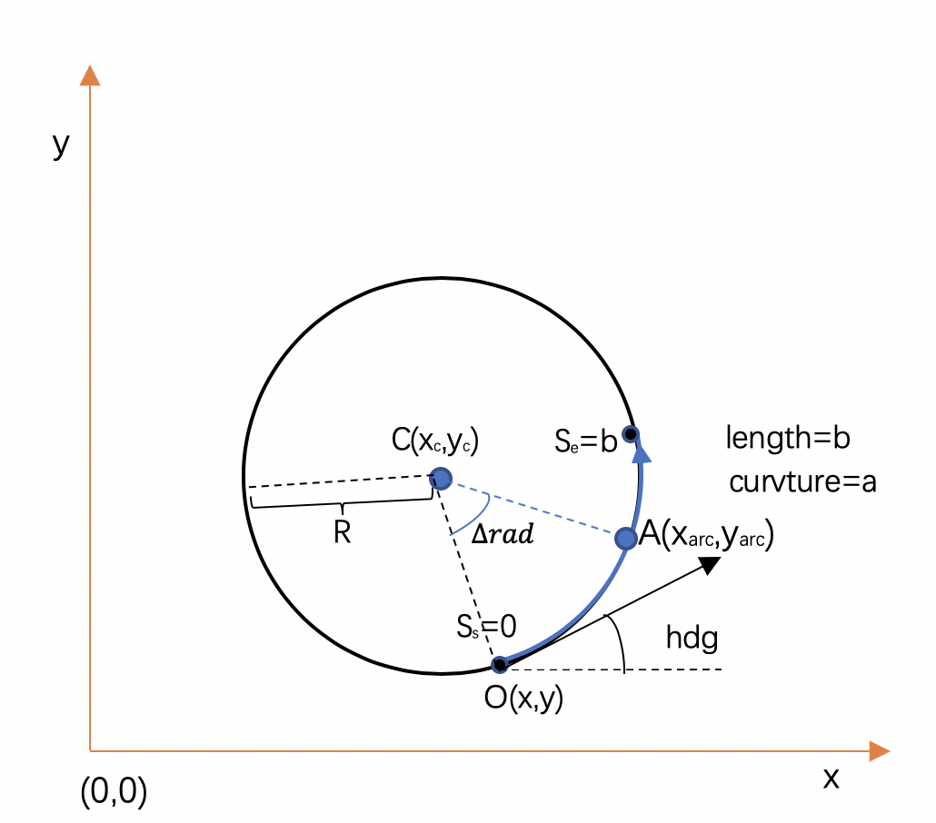

Figure 4.3: Analysis Geometry Arc

As figure 4.3 illustrate, first decide the radius of the arc using the following equation:

$R=|1/curvature|$ (4.3)

Then according to the curvature symbol to decide the center coordinate *C*(*x*c,*y*c) of the circle.

$x_{c}=cos(hdg±Π/2-Π)*R$ +x(4.4)

$y_{c}=sin(hdg±Π/2-Π)*R$*+y* (4.5)

Then according to the center coordinate of the circle to calculate the point which on the arc.

$x_{arc}=x_{c}+cos(hdg±rad+-Π/2)*R$ (4.6)

$y_{arc}=y_{c}+sin(hdg±rad+-Π/2)*R$ (4.7)

Lastly repeat above procedure using variable *rad*.

$rad=∆s/{length}_{arc}$ (4.8)

|  |
| --- |
| **Algorithm**: calculate point set of geometry arc |
| 1. *radius<- abs(1/curvature)* 2. for*s* in range(0,*arc.length*) step +0.1 3. if *curvature* <0 4. x_*center* <- *cos(hdg+PI/2-PI)*radius* 5. y_*center* <-*sin(hdg+PI/2-PI)*radius* 6. *xarc <- x_center+cos(hdg-raidus+PI/2)*s* 7. *yarc <-y_center+sin(hdg-radius+PI/2)*s* 8. if *curvature* >=0 9. *x_center <-cos(hdg-PI/2-PI)*radius* 10. *y_center <-sin(hdg-PI/2-PI)*radius* 11. *xarc <-x_center+cos(hdg+radius-PI/2)*s* 12. *yarc <-y_center+sin(hdg+radius-PI/2) $∆$*s*   13: returen point set of geometry arc |

Thirdly analysis geometry spiral. According to official instruction, it recommends to use it offers function odrSpiral to analysis the spiral, so transfer the official code which written by C to C#. The odrSpiral prerequisite is assumed geometry start point *curvature* is 0 as the figure 4.4 point *O*(*x*s, *y*s) shown.

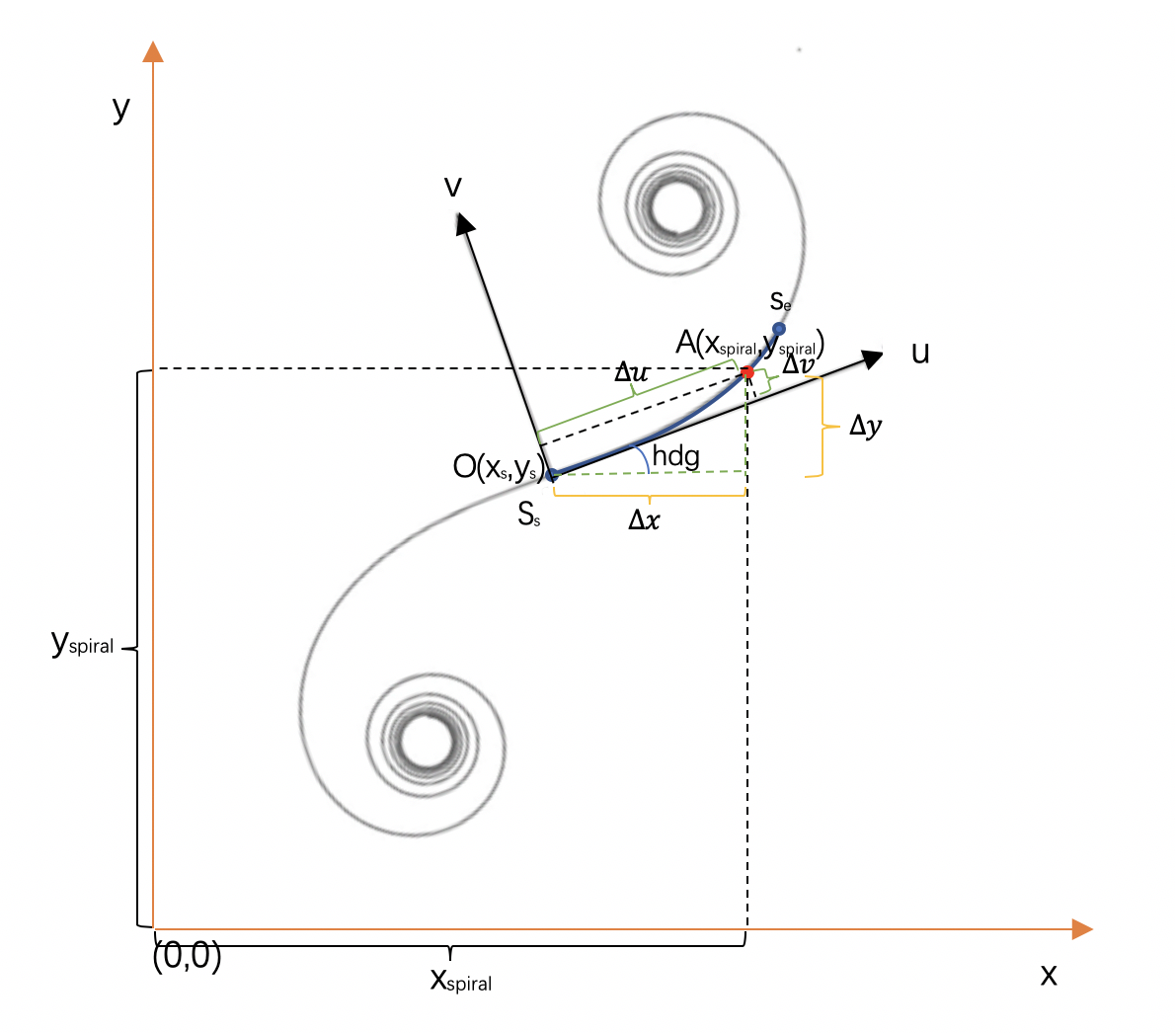

Figure 4.4: Analysis Geometry Spiral

The function needs two parameter *cdot* and *∆s*. It returns two value *∆u* and *∆v* in inner coordinate system illustrated in figure 4.4. the procedure of draw geometry spiral is described as the following steps:

1. use parameter $∆s$ and cdot and function *odrSpiral* to calculate $∆u$ and $∆v$ in the inner coordinate system. According to the following equation:

$∆u$ =odrSpiral($∆s,cdot$).x (4.9)

$∆v$ =odrSpiral($∆s,cdot$).y (4.10)

1. Transfer $∆u$ to $∆x$ and $∆v$ to $∆y$ using the following equation:

$∆x$ = $∆u$*cos(*hdg*)- $∆v$*sin(*hdg*) (4.11)

$∆y$ = $∆u$*sin(*hdg*)+ $∆v$*cos(*hdg*) (4.12)

1. Calculate Point *A(xspiral, yspiral)* in inertial coordinate system according to point *O(xs, ys)* and $∆y$ using the following equeation:

xspiral=xs+ (4.13)

yspiral=ys+ (4.14)

1. repeat procedure 1-3 according to variouble $∆s$ increase progressively until $∆s$ =lengthspiral.

In the real situation, the *curvStart* is not always being 0. For example, in figure 4.5 shown, obviously *curvStart* of point S is not equal to 0. How to draw geometry spiral in this situation when the prerequisite of function odrSpiral is assumed *curvStart*=0?

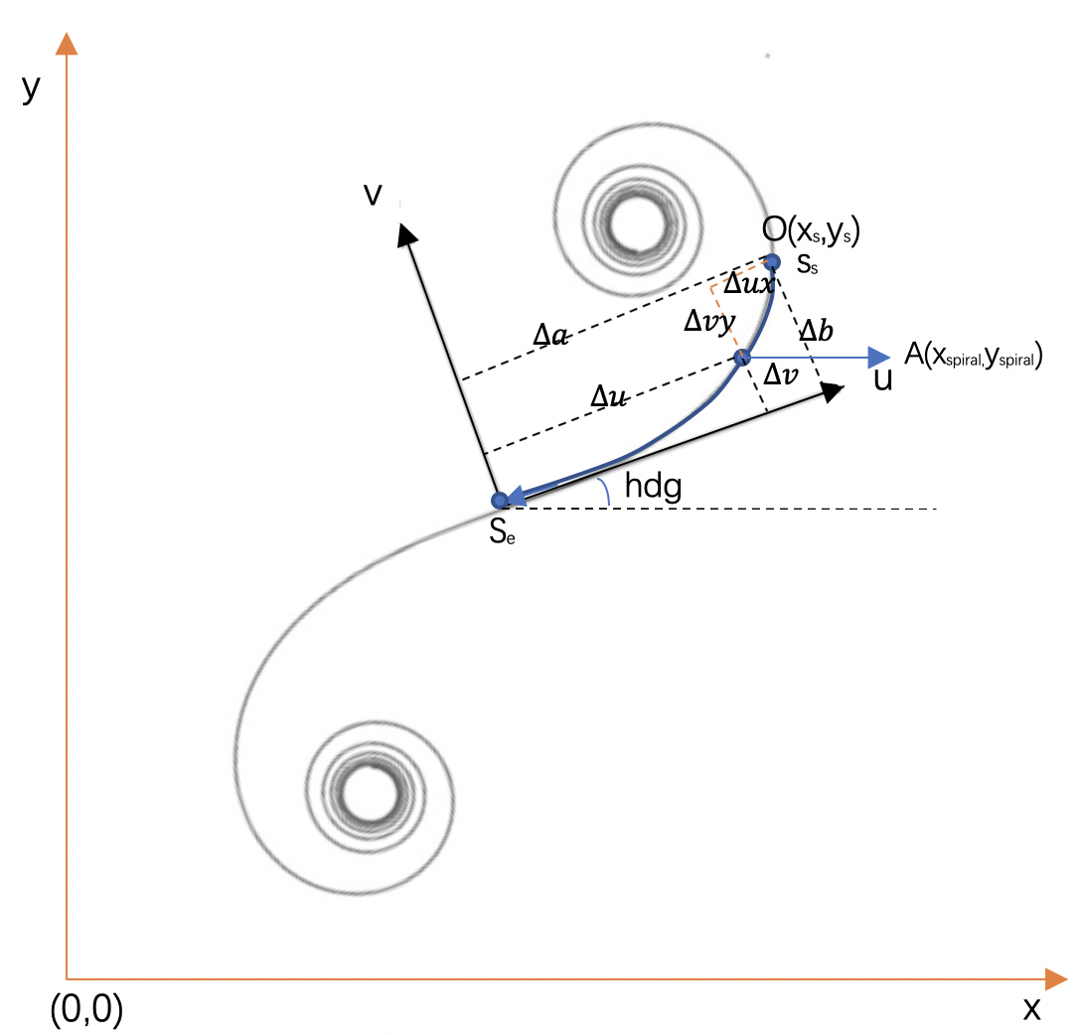



Figure 4.5: Calculate Geometry Spiral

An alternative way is that through a series of calculations to get the point coordinate set which belongs to the geometry spiral in the inner coordinate system and rotate the point coordinate set to the normal situation (shown in figure 4.6), then rotate and translation the point coordinate set to inertial coordinate system as above already illustrated. The detail is illustrated in the following:

1. Assume the *curvEnd* is *curvStart* and *curvStart* is *curvEnd*, so that can get two value $∆a$ and $∆b$ (shown in figure 4.5) using the following equation:

$∆a$ = *odrSpiral(lengthspiral,* *cdot).x* (4.15)

$∆b$ = *odrSpiral(lengthspiral , cdot).y*  (4.16)

1. Calculate the point coordinate in the geometry spiral using the following equation (shown in figure 4.5):

$∆u$ = *odrSpiral($∆s$, cdot).x*  (4.17)

$∆v$*= odrSpiral($∆s$, cdot).y*  (4.18)

1. The point *A(x*spiral,*y*spiral) in inner coordinate system is calculate by following equation (shown in figure 4.5) and point *O*($∆a$, $∆b$) in inner coordinate coordinate system:

*x*spiral=-= (4.19)

*y*spiral=-= (4.20)

1. Repeat step 2-3 according to variable $∆s$ decrease progressively until $∆s$ =0.
2. Rotate the point set to figure 4.6 shown in order to curvStart is 0 in inner coordinate system using the following equation:

$∆ux'$*= $∆ux$*cos(hdg0)-*sin(hdg0)* (4.21)

*=*cos(hdg0)+*sin(hdg0)*  (4.22)

1. Transfer inner coordinate point set to inertial coordinate system using the following equation:

*x=xs+cos(hdg) $∆ux'$*-sin(hdg) $∆vy'$\**  (4.23)

*y=ys+cos(hdg) $∆ux'$*+sin(hdg) $∆vy'$\**  (4.24)

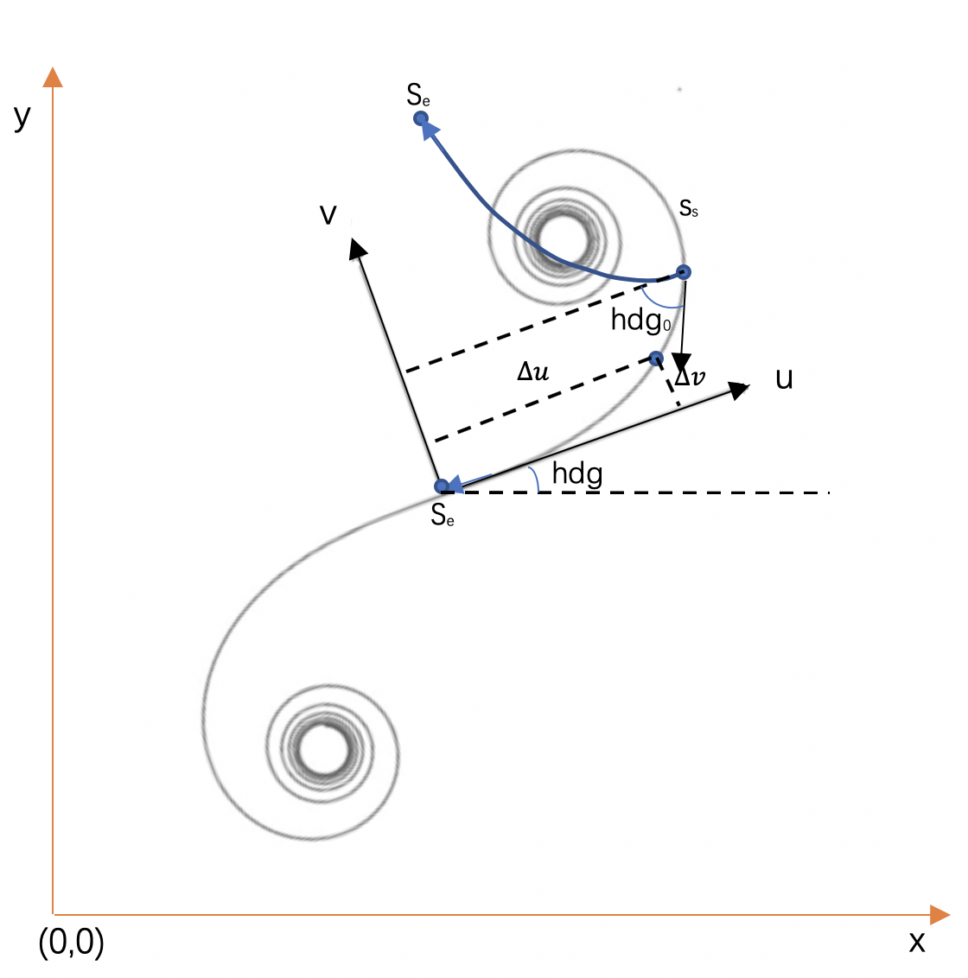

Figure 4.6: Roate Geometry Spiral

|  |
| --- |
| **Algorithm**: calculate point set of geometry spiral |
| 1. If *curvstart* = 0 2. for *l* in range(0,*spiral.length*) step +0.1 3. *x_sample=odrspiral(l,codt).x* 4. *y_sample=odrspiral(l,codt).y* 5. *x_rotate=x_sample*cos(hdg)-y_sample*sin(hdg)* 6. *x_roate=y_sample*sin(hdg)+y_sample*cos(hdg)* 7. If *curvstart* != 0 8. *thdg=length*/2\**curvstart* 9. *x_end=odrspiral(spiral.length,codt).x* 10. *y_end=odrspiral(spiral.length,codt).y* 11. for *l* in range(0,*spiral.length*) step -0.1 12. *x_sample=x_end-odrspiral(l,codt).x* 13. *y_sample=y_end-odrspiral(l,codt).y* 14. *x_rotate=x_sample*cos(hdg+thdg)-y_sample*sin(hdg+thdg)* 15. *y_rotate=y_sample*sin(hdg+thdg)+y_sample*cos(hdg+thdg)* 16. returen point set of geometry spiral |

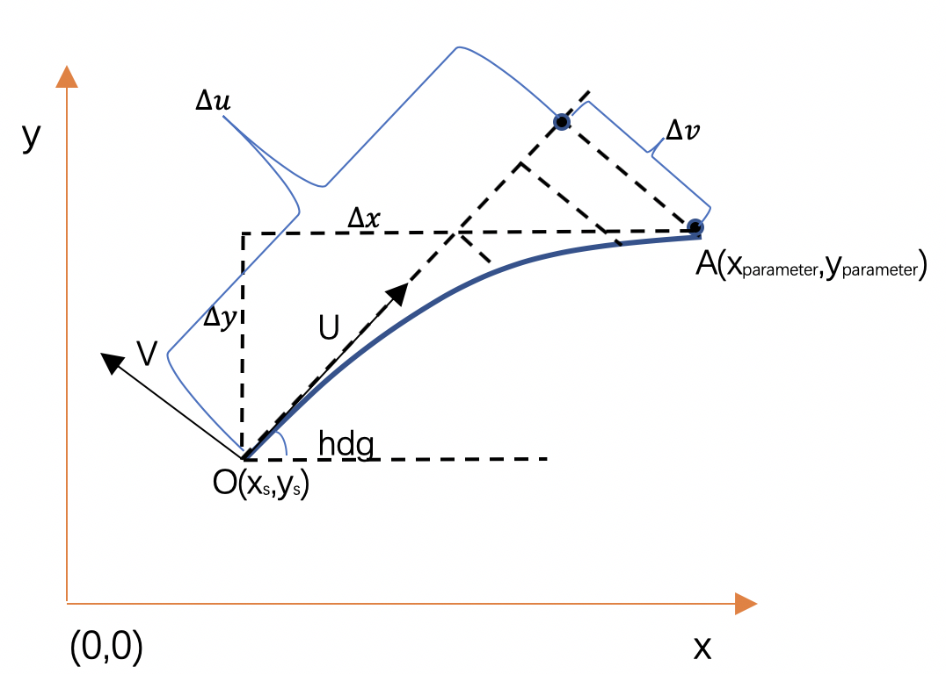

Figure 4.7: Analysis parameter poly

Fourth analysis geometry parameter poly. The way to analysis parameter poly geometry is illustrated in following step:

1. Calculate $∆u$ and $∆v$ as the figure 4.7 shown using following equation:

$∆u$*= aU + bU * p + cU * p * p + dU * p * p * p*  (4.25)

$∆v$ = aV + bV * *p* + cV * *p* * *p* + dV* *p* * *p* * *p*  (4.26)

*p*= $∆s$/lengthparameter (4.27)

1. Repeat step 1 according to variable $∆s$ increase progressively until $∆s=$ lengthparameter
2. Transfer inner coordinate system point set to inertial coordinate system using the following equation:

*xparameter=xs +*cos(hdg)- $∆v$*sin(hdg)* (4.28)

*yparameter=xs +*sin(hdg)+ $∆v$*cos(hdg)*  (4.29)

|  |
| --- |
| **Algorithm**: calculate point set of geometry poly |
| 1. for *l* in range(0,poly.length) step +0.1 2. *P<- l/poly.length* 3. *<- aU + bU * p + cU * p * p + dU * p * p * p* 4. *<- aV + bV * p + cV * p * p + dV* p * p * p* 5. Return point set of geometry poly |

Fifth analysis elevation. After analysis geometry node, can establish a geometry road in two-dimensions, they consist of (*x*, *y*) point set. Elevation node gives the third dimension to let the geometry road become three-dimensions (*x*, *y*, *z*).

In Format Specification, Rev. 1.5 [3], there is a formula :

$ele=a+b*ds+c*ds*ds+d*ds*ds$ (4.30)

*ds* is the absolute distance along the road section.

Meanwhile, each *ds* match a point(*x*, *y*), so can according to the *ds* to find which point(*x*, *y*) match which *z* (as figure4.8 illustrate).

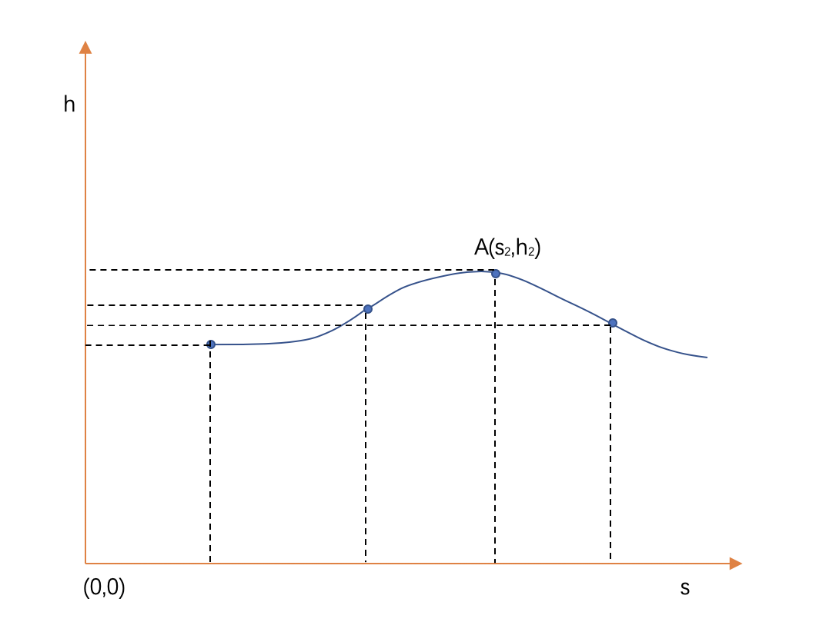

Figure 4.8: Analysis Elevation

|  |
| --- |
| **Algorithm**: calculate the elevation along the road reference (chord) line |
| 1. for *I* in range(0,*elevation.number*) step+1 2. for *j* in range(0,*elevation.length*) step+1 3. *z_elevation* <- 4. Return z_elevation set |

Sixth analysis max width of road. A road is a face, not a line, so should give each road reference line section a width to establish the road face. The width of each road section is determined by the width node record. Each road section has several laneSection nodes, each laneSection node has several lanes, each lane has several width nodes. The width of the road section is determined by the sum of width node. As the figure 4.9 shown, though road laneSectionA left width is *aa*, right width is *bb* but laneSectionB left width is *aa*+*c*, right width is *bb*+*c*, the road section left width is *aa*+*c*, right width is *bb*+*c*.

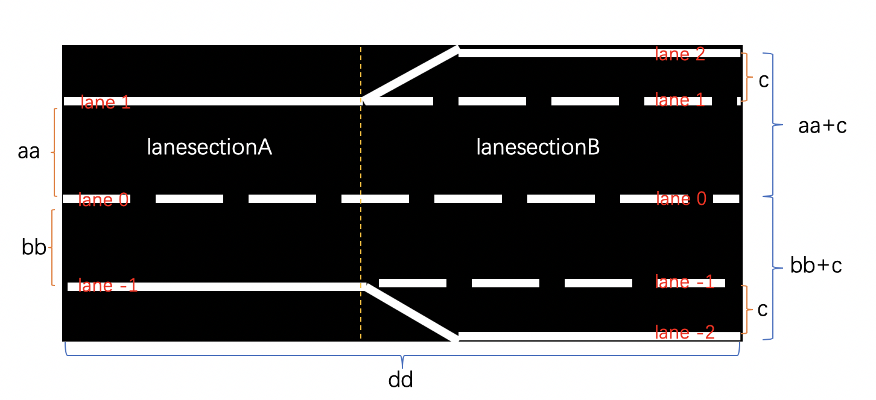

Figure 4.9: Max Width

|  |
| --- |
| **Algorithm**: calculate the width of the road section |
| 1. for *k* in range(0,*lane.length*) step+1 2. for *p* in range(0,*lane[k].length*) step+1 3. for *m* in range(*lane[k][p].length*) step+1 4. *max_left <- sum(lane[k][p][m].left_width)* 5. *max_right <- sum(lane[k][p][m].right_width)* 6. Return max_left and max_right |

Seventh analysis signals. During analysis signals node record, the most import is to put the signal in the right position and right direction.

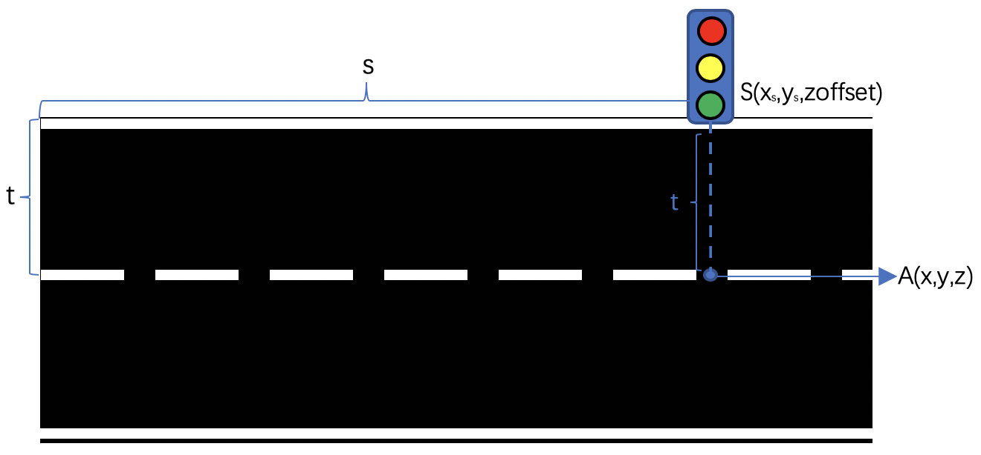

Figure 4.10: Signal Position

According to the Format Specification, Rev. 1.5 [3], parameter *s* is the absolute position (track coordinate system) along the road section, you already knew that each *s* match a point(*x, y, z*) which in road reference line in inertial (world) coordinate system, as figure 4.10 shown the relationship between *S(xs, ys, zoffset)* and *A(x, y, z).* The parameter *t* is the offset in the direction of vertical point A. So the way to find the right position is to illustrate in the following:

1. Using parameter *s* to find point *A(x, y, z).*

2. Using parameter *t* to calculate the point *s(xs , ys , z).*

3. Replace *z* in point *s(xs, ys, z)* using parameter zoffset and get new point *s(xs, ys, zoffset).*

According to Format Specification, Rev. 1.5 [3], orientation is the "+" = valid in positive track direction "-" = valid in negative track direction "none" = valid in both directions.

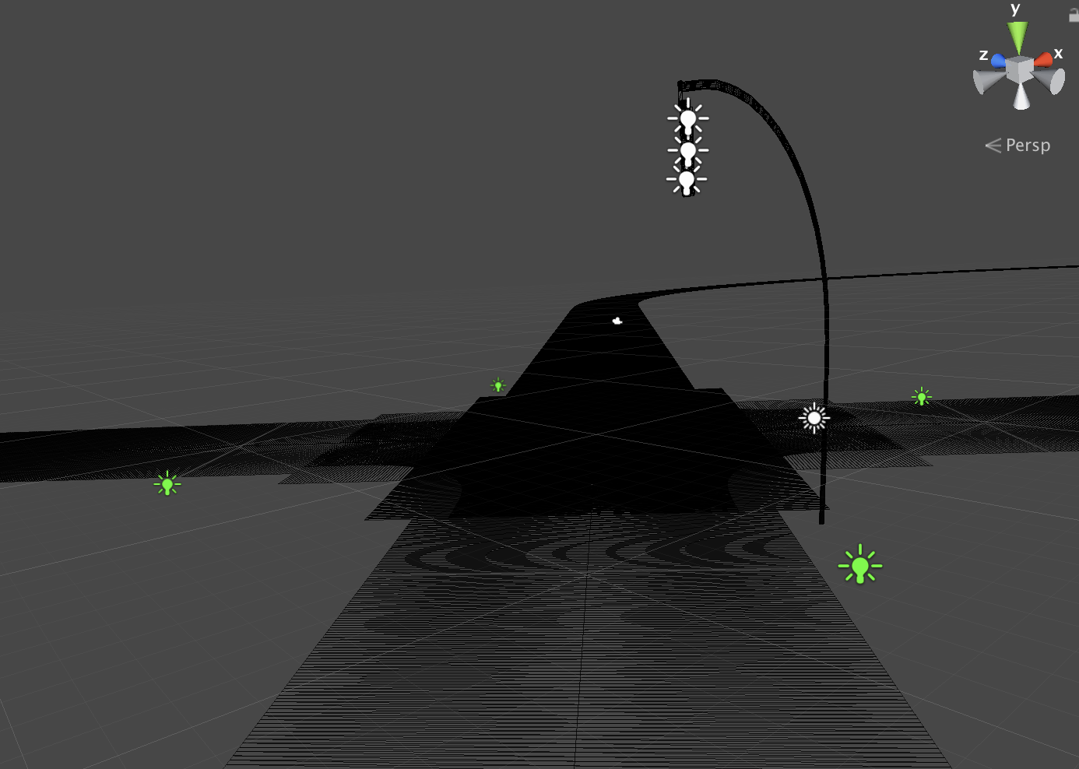

Figure 4.11: Right Direction

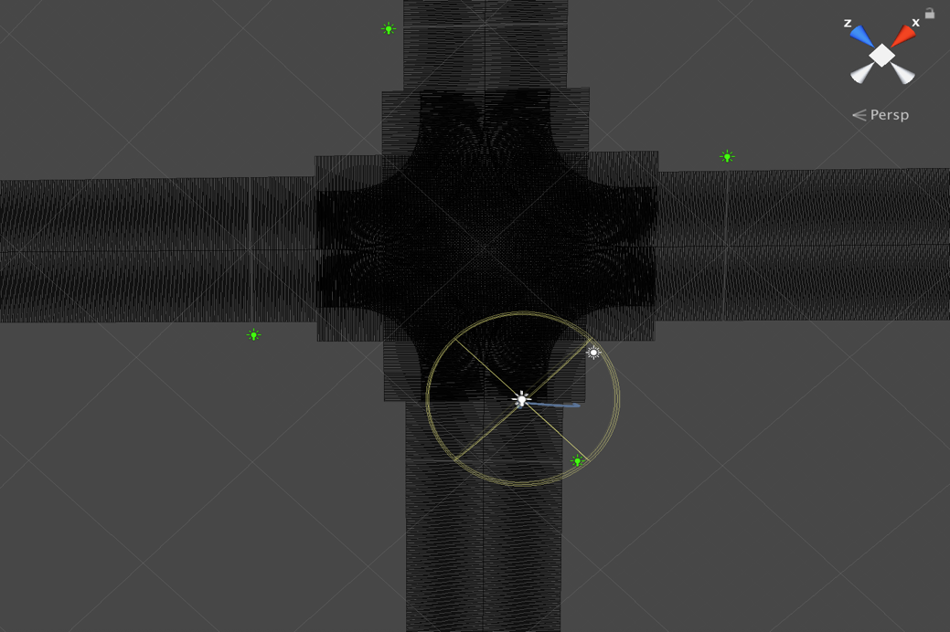

Figure 4.12: Right Direction

As figure 4.11 and figure 4.12 shown, after correctly put the signal in the right position, they should rotate the signal in the right direction which the signal

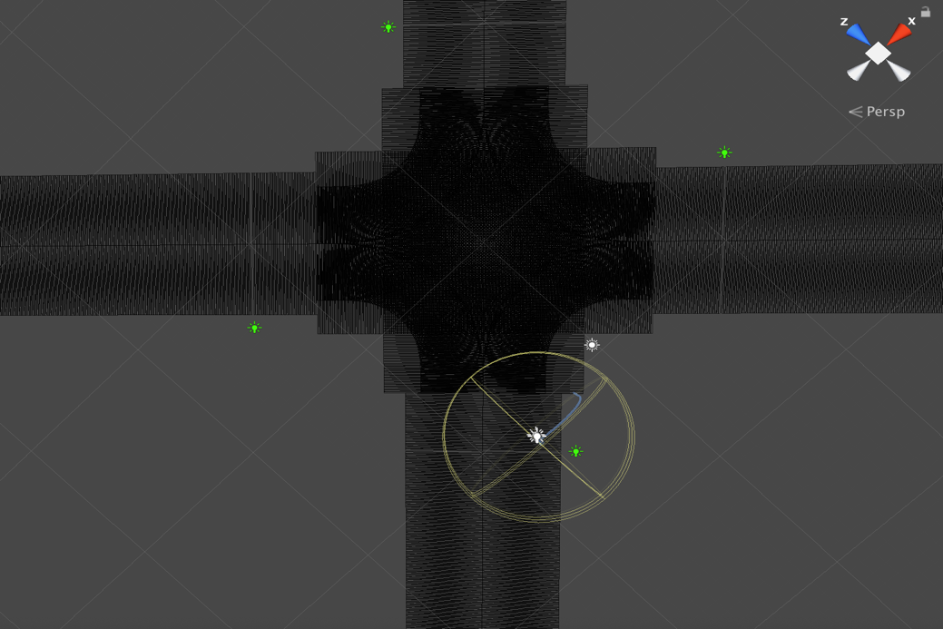

Figure 4.13: Wrong Direction

vertical the road direction. As figure 4.13 shown, though it is in the right position, it is not in the right direction.

The way to rotate the signal in the right direction is illustrated in the following step:

1. Set the direction of the signal on default as a model in Unity3D.
2. Calculate the direction of the road section which the signal belong to.
3. Rotate the signal model according to the angle which between the signal default direction and the direction of the road.

Lastly, create road mesh structure. In Unity3D, face is based on triangle. This applies to almost every representation of 3D geometry on the computer. The alternative voxel graphic is not widespread. Graphics cards are optimized for triangles.

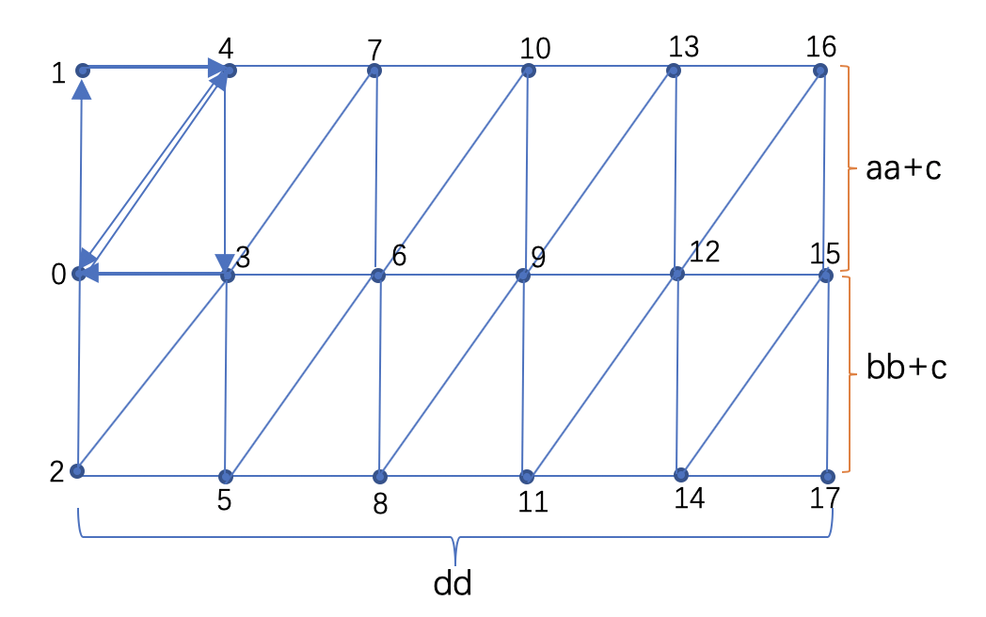

Figure 4.14: Road Mesh Triangulation Case

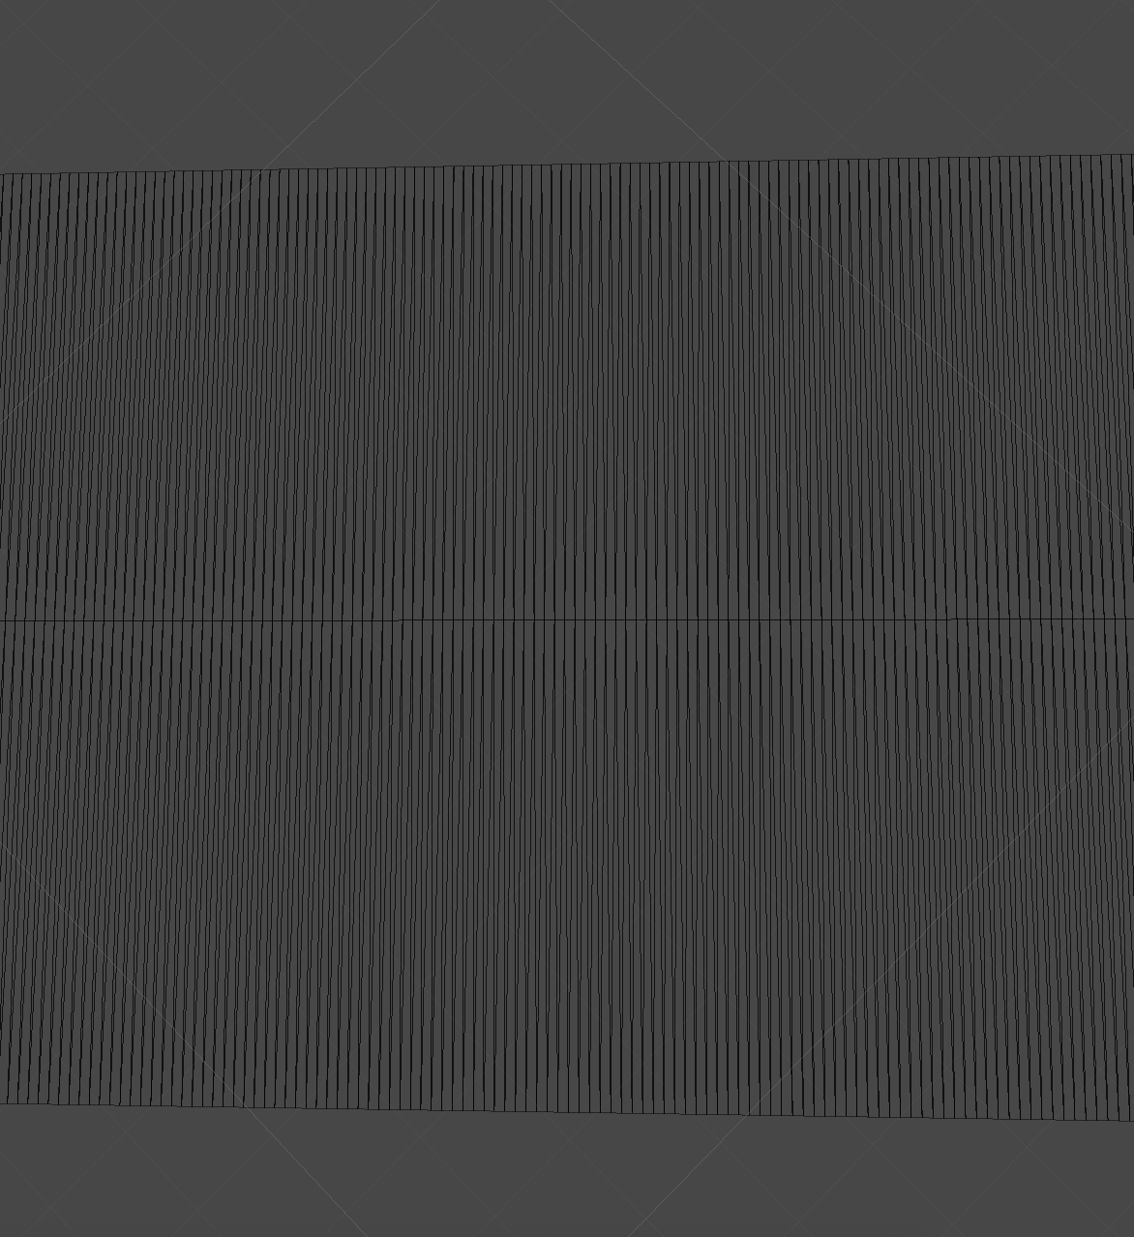

Figure 4.15: Road Mesh In Unity3D

As figure 4.15 shown, it illustrates the case of road mesh in Unity3D. Obviously, the line section is composed of many triangles. And not only line section, arbitrary geometry can be composed of many different triangles.

4.2 Combine Program Structure

Combine each module mentioned before in this chapter, come out with figure 4.16 and figure 4.17 a program flow chart and a function diagram. According to the program flow chart can establish a road network in Unity3D shown in figure 4.18 figure 4.19 and figure 4.20.

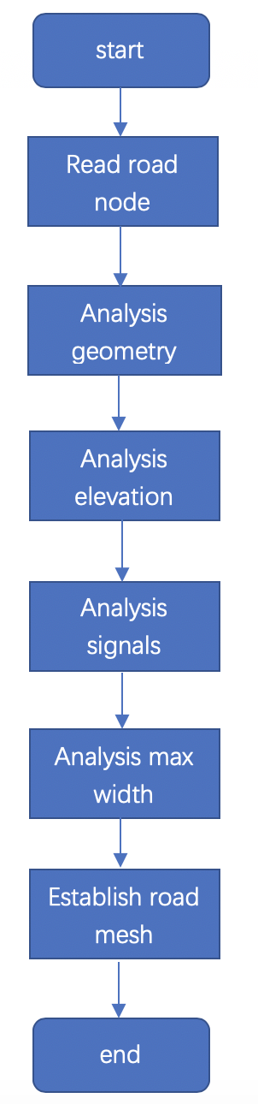

Figure 4.16: Program Flow Chart

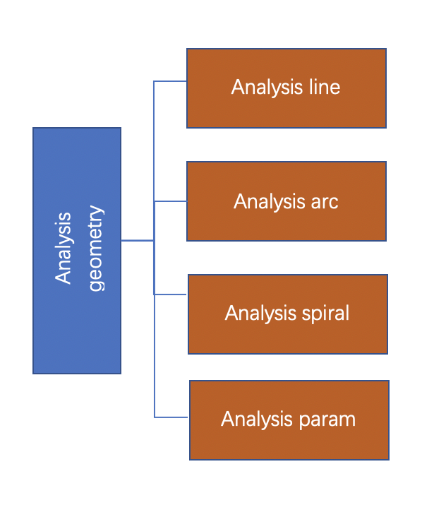

Figure 4.17: Function Diagram

Figure 4.17 shows inner structure of module Analysis geometry. It has four sub‑functions. The program will execute the corresponding function according to the different tag below the geometric node.

But it does not has the lane texture, in the next will explain how to correctly generate lane texture in Unity3D.

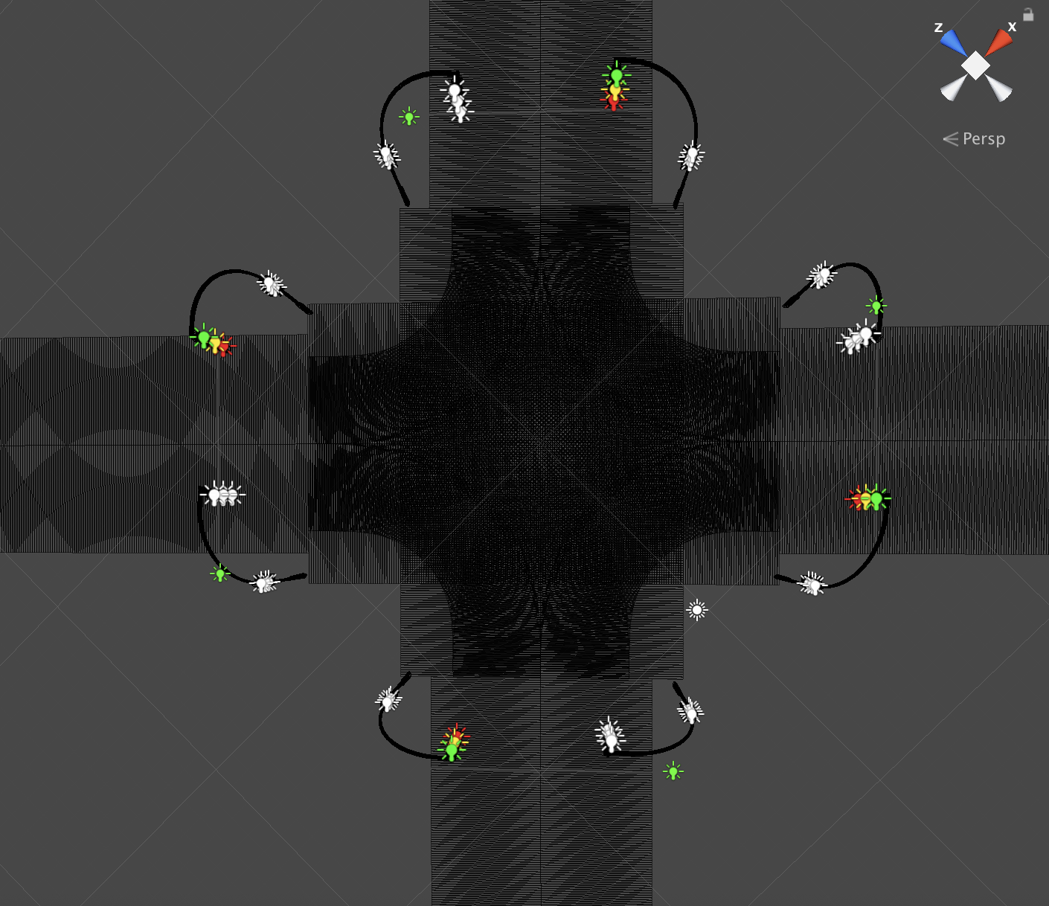

Figure 4.18: Road Network 1

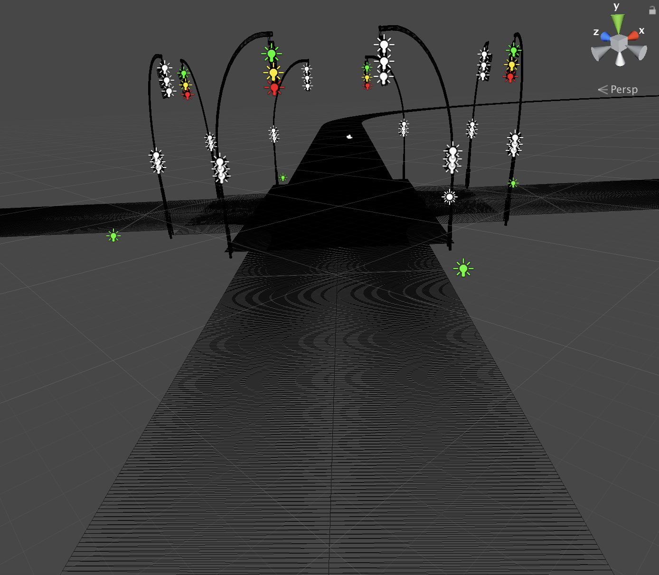

Figure 4.19: Road Network 2

Figure 4.18, figure 4.19 and figure 4.20 are created from the same OpenDRIVE file. Figure 4.18 is the top view of the crossing in the road network. Figure 4.19

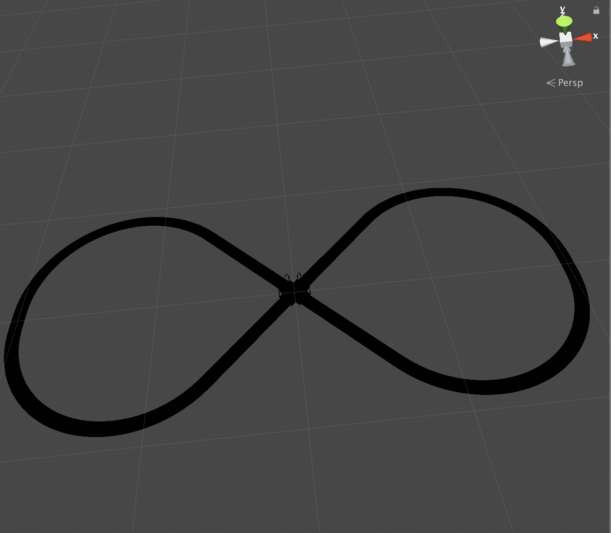

Figure 4.20: Road Network 3

is the side view of the crossing in the road network. Figure 4.20 is the panoramic view of the road network.

|  |
| --- |
| **Algorithm**: establish road network mesh in Unity3D |
| 1. for I in range(0,road.number) step+1 2. create geometry 3. analysis elevation   4: analysis signals  5: create road mesh  6: Return road network mesh |

4.2 Texture Generation

After research, it is better to dynamic draw lanes on texture according to the width record in every road node and apply the texture on the road section.

4.2.1 Texture Introduction

Normally, the mesh geometry of an object only gives a rough approximation of the shape as figure 4.11 shown while most of the fine detail is supplied by textures. A texture is a image that is applied over the mesh surface as shown in figure 4.21. You can think of a texture image as though it were stretched on the mesh geometry at appropriate positions [10].

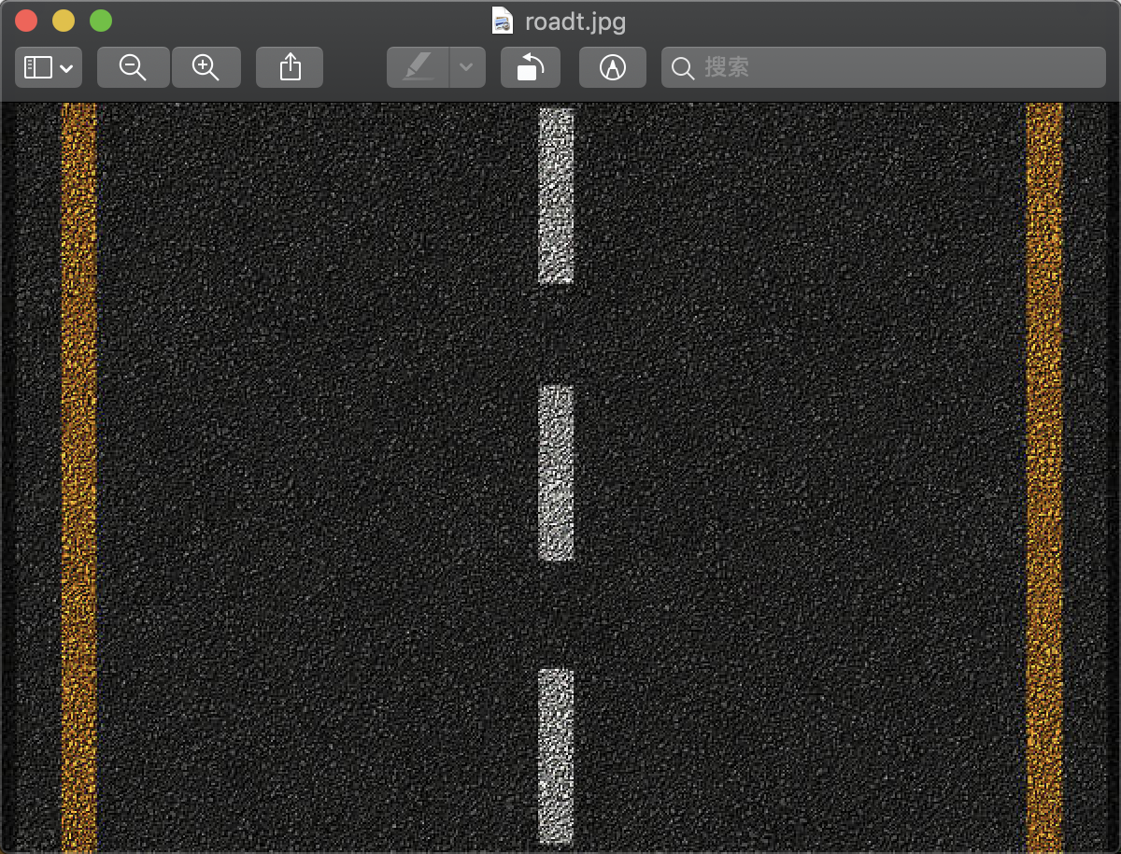

Figure 4.21: Texture

4.2.2 Draw Texture

The length of the road section is equal to the width of the texture, and the road max left + road max right=the height of the texture.

After deciding the size of the texture and draw a blank texture, will draw lanes on the texture.

According to Format Specification, Rev. 1.5 [3], you know all the lanes are described along the lane reference line. And the lane reference line is described along the road reference line. So before drawing the lanes, you have to decide the road reference line and lane reference line first.

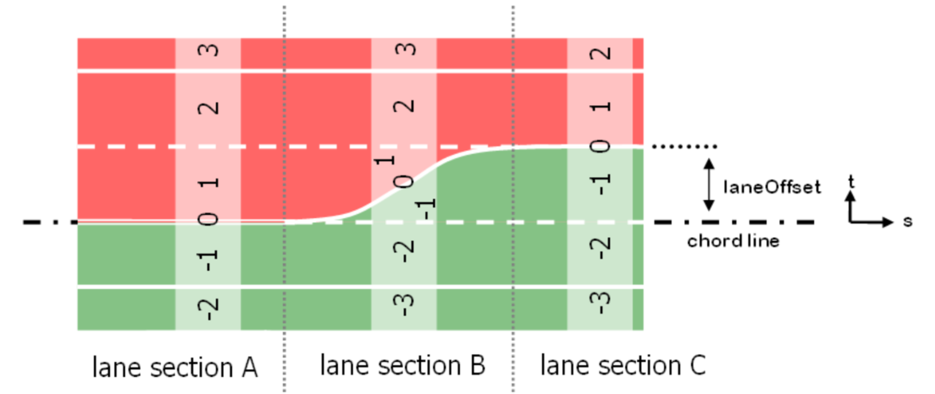

Figure 4.22: LaneOffset [2]

As figure 4.22 shown, lane 0 is lane reference line and it is described by road reference (chord) line and laneOffset. Each lane has a width record means the width of the lane. When the lane is in the red (left) area the id of the lane is positive and in the green (right) area, the id is negative [3]. The outer border of the lane is the track of the width record. So each lane has a width track, and the next width lane track is based on last width lane track. For example, in figure 4.22, lane 1 outer border is the broken white line drawn along the lane 0 according to the lane 1 width record. The lane 2 outer borders soild white line drawn along the lane 1 outer border line according to lane 2 width record.

Actually, it is complex to draw the lane line which is the white line (broken and soild) in figure 4.22. you have to consider in which area what type of the line is as well as what the track of the line is. Next will explain a simple situation to easily understand.

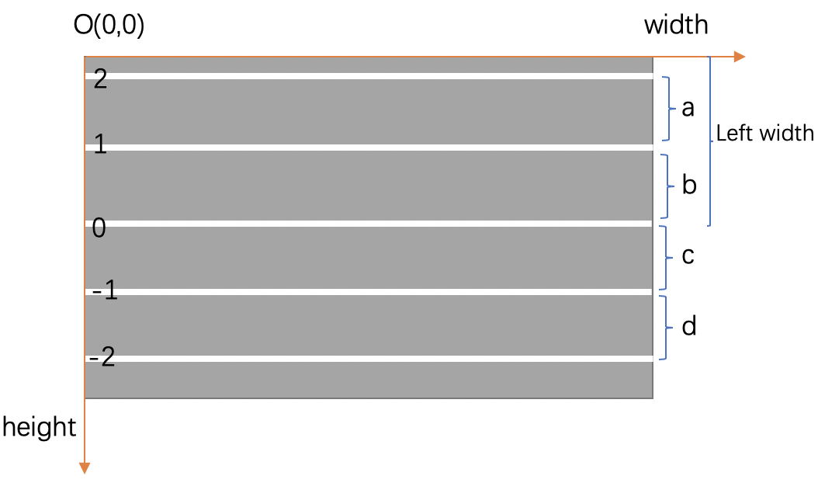

Figure 4.23: Lane Texture

As figure 4.23 show, it is a road texture with five - lane outer border tracks in the texture coordinate system. The number is the lane id. The variate (*a,b,c* and *d*) is the width of each lane calculated by the width record.

Lane 1 border is calculate by following equation:

*Lane1=Leftwidth-b*  (4.31)

Lane 2 border is calculate by following equation:

*Lane2=Leftwidth-b-a*  (4.32)

Lane -1 border is calculate by following equation:

*Lane-1=Leftwidth+c* (4.33)

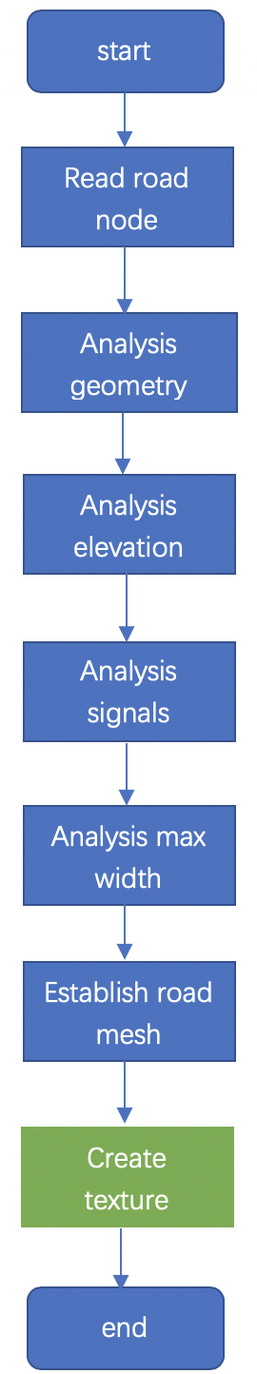

Figure 4.24: Program Flow Chart

As figure 4.23 shown after adding create texture module to the program, can draw the road network as figure 4.25, figure 4.26, and figure 4.27 shown. They have the lanes on the road face.

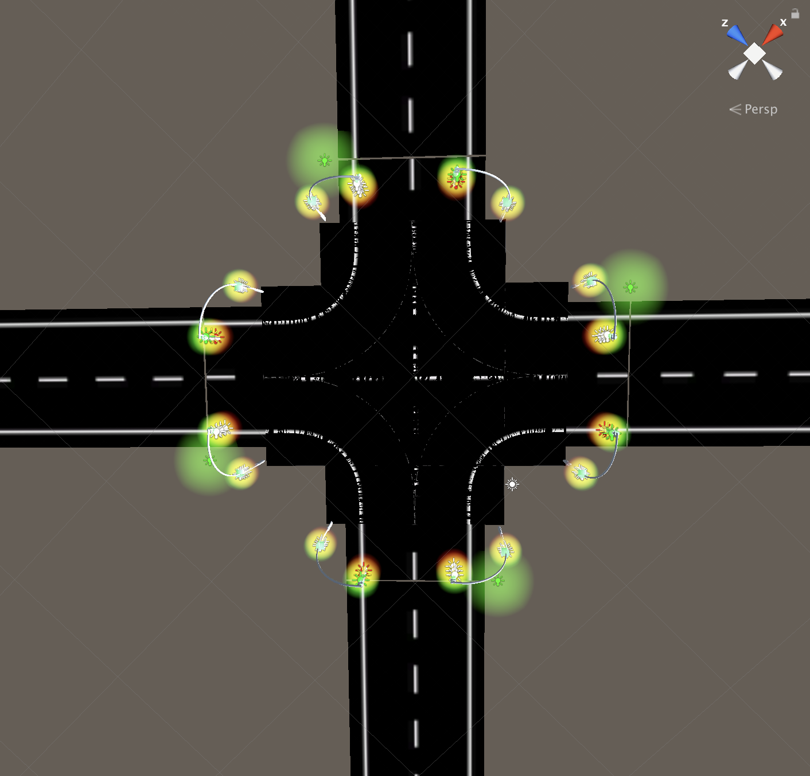

Figure 4.25: Road Network With Texture 1

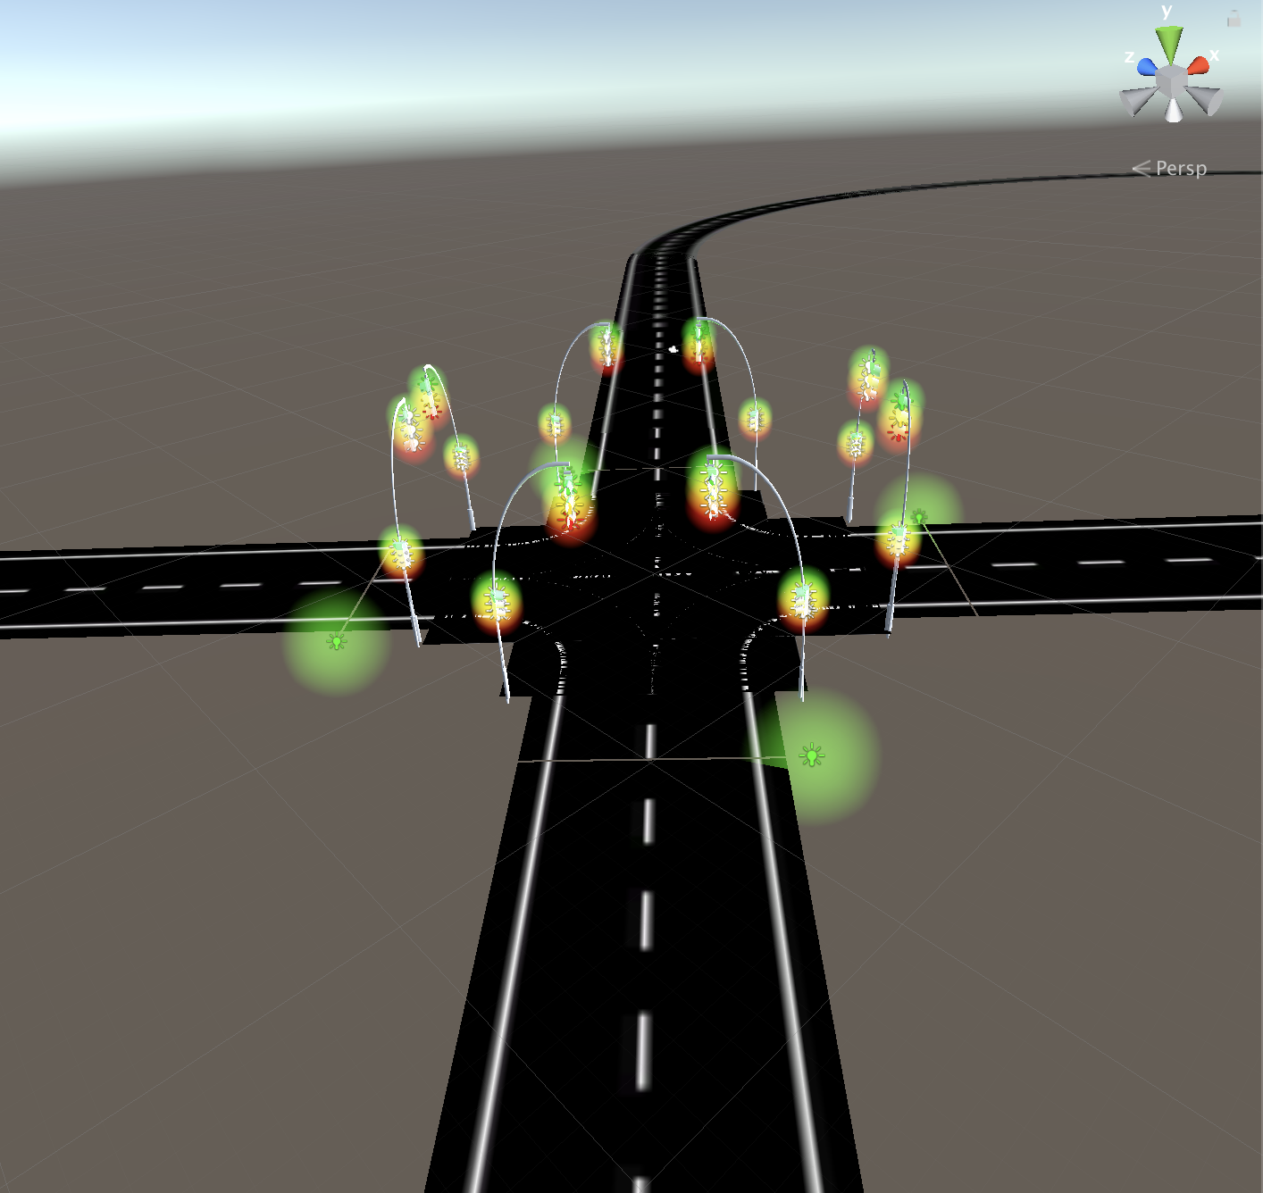

Figure 4.26 road network with texture 2

Figure 4.25, figure 4.26 and figure 4.27 are created from the same OpenDRIVE file. Figure 4.25 is the top view of the crossing in the road network. Figure 4.26

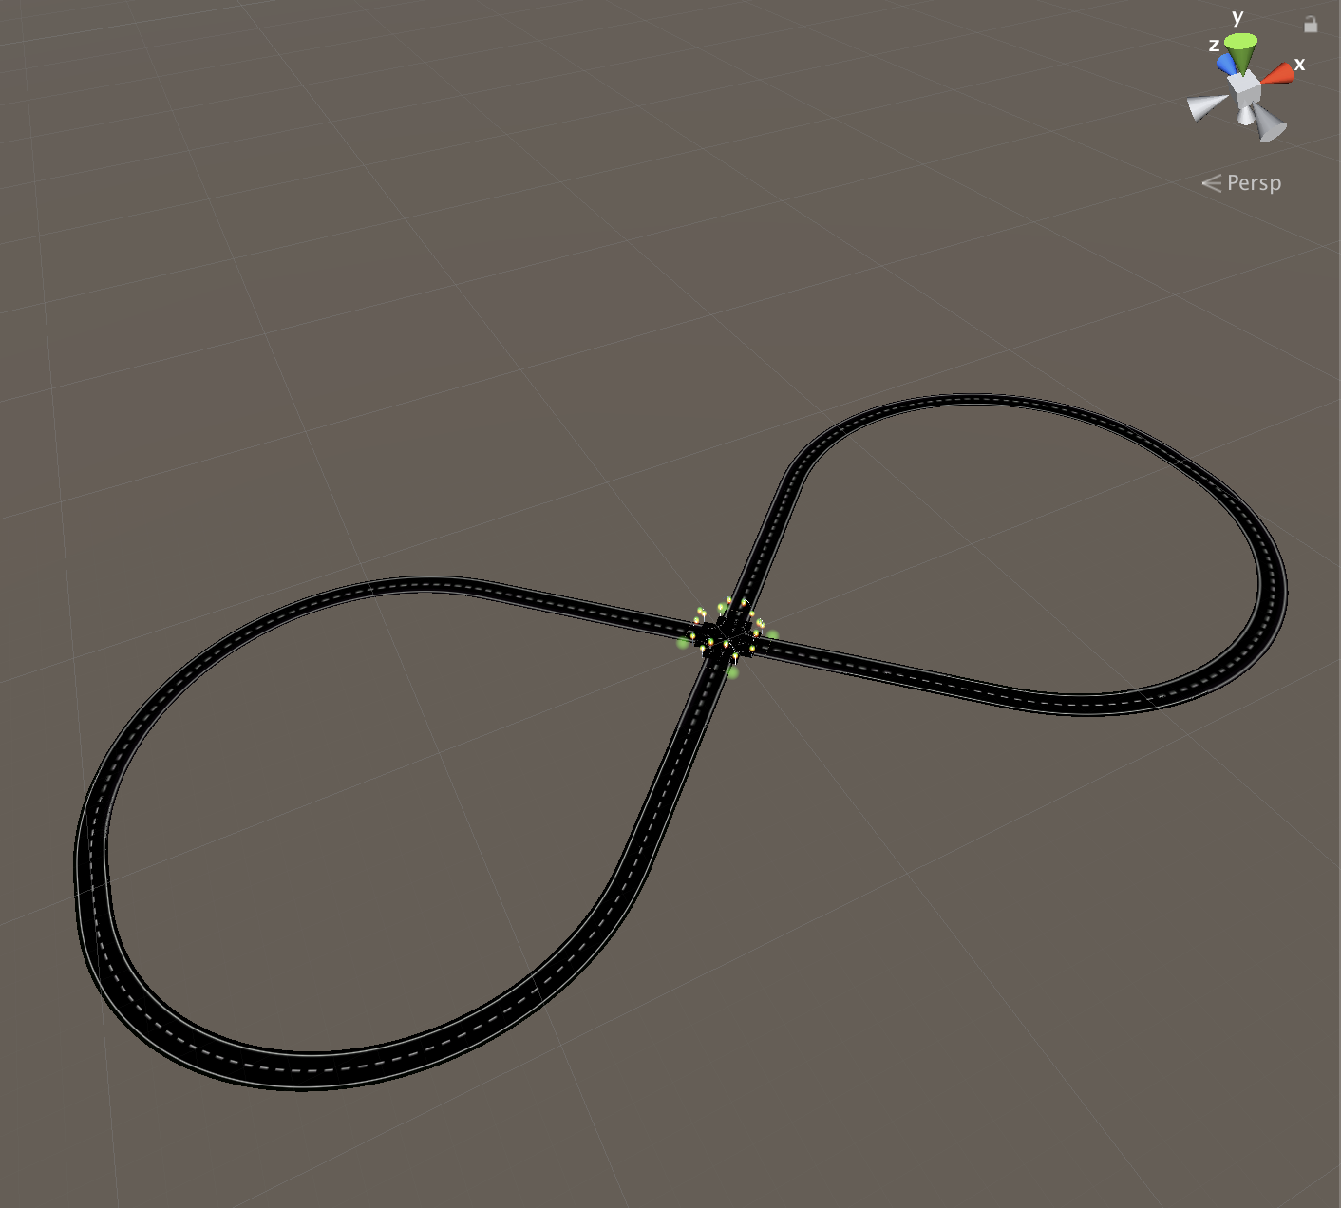

Figure 4.27: Road Network With Texture 3

is the side view of the crossing in the road network. Figure 4.27 is the panoramic view of the road network.

4.3 Junction Problem

After creating road texture and apply it on the road section, everything looks good as figure 4.25, figure 4.26 and figure 4.27 shown. But when applying different color on the road texture, something weird happened. As figure 4.28 and figure 4.29 shown, there are some flickers on the crossing area.

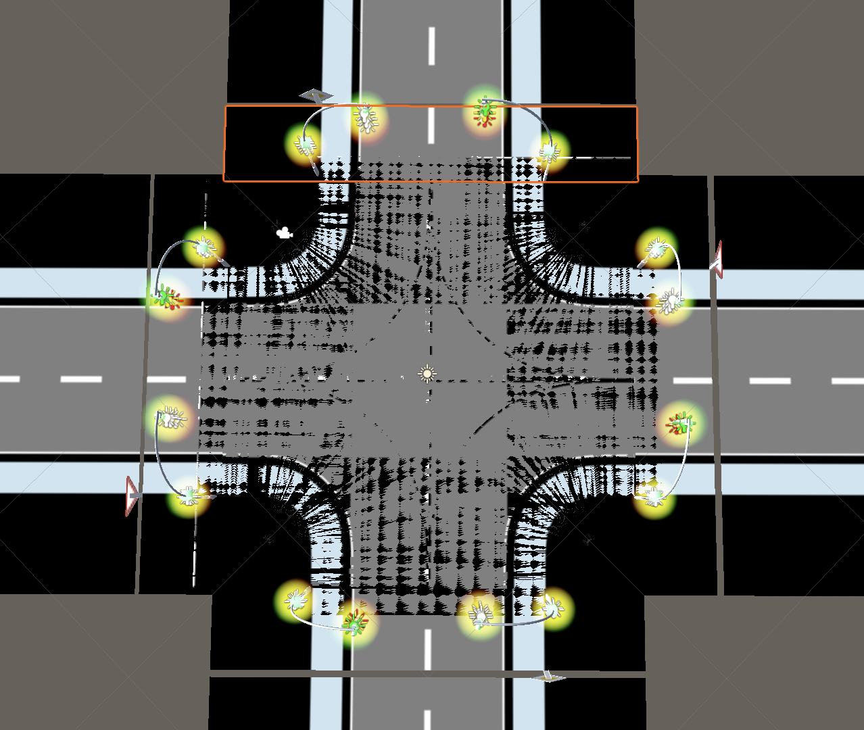

Figure 4.28 Flicker Crossing 1

After research, found that it is because many road section layers overlap (as figure 4.30 shown), the computer doesn’t know show which layer first. The first solution is to set different road section layer different height, as figure 4.31 shown, the height of road section layer with orange bound is bigger than other road section layers, but this will make road network face not smooth and cover other road section layers. The second solution is to set the color of the area which has

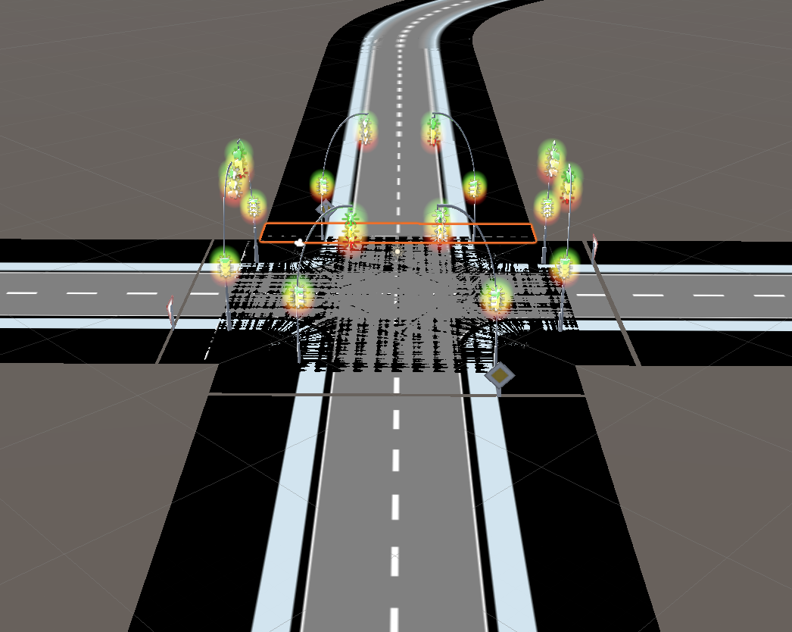

Figure 4.29 Flicker Crossing 2

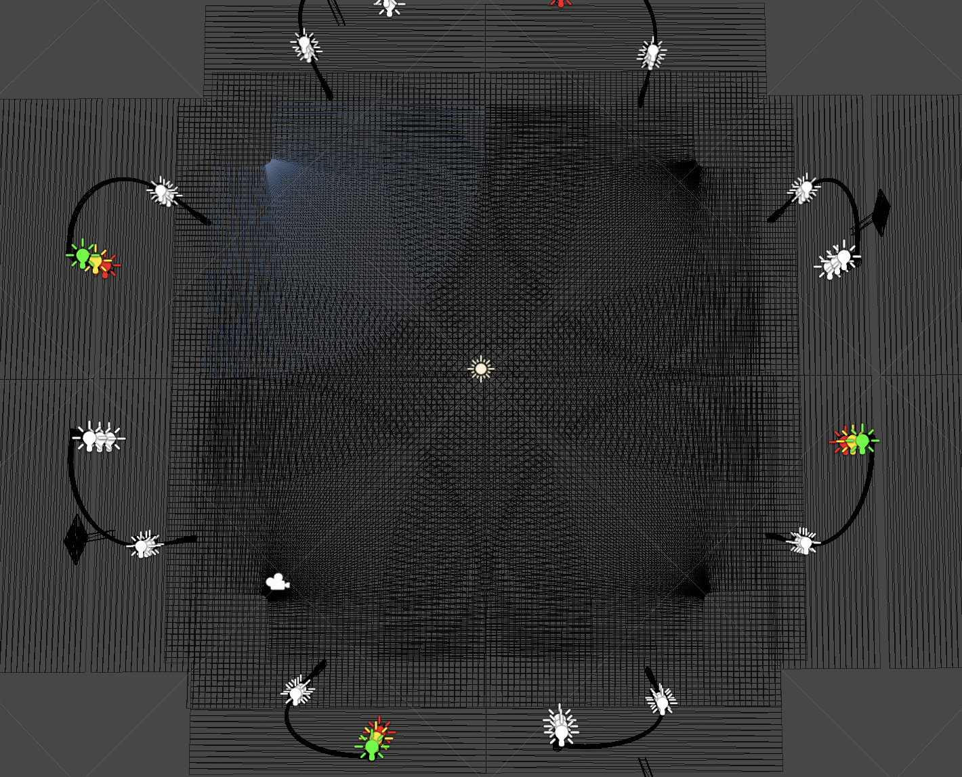

Figure 4.30 Layers Overlap

overlap and the area which not belongs to lane be transparent, as figure 4.32 shown. This time looks good again. But if change another junction as figure

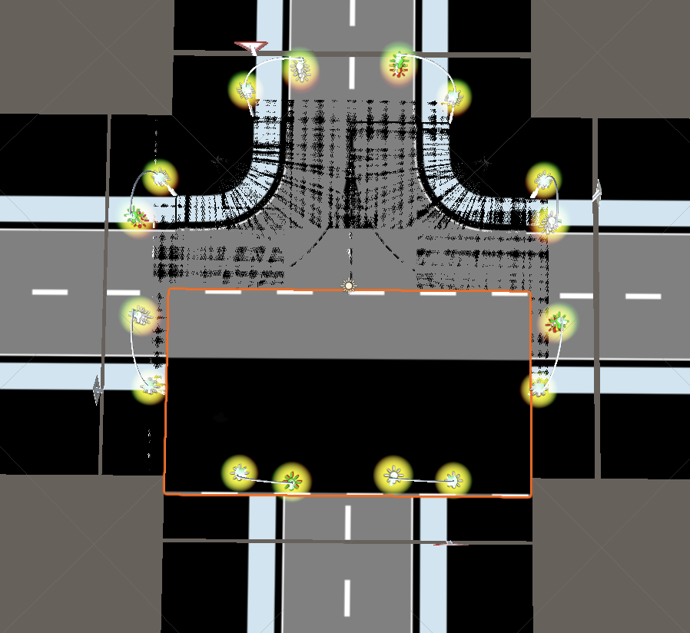

Figure 4.31 Change Layer Height

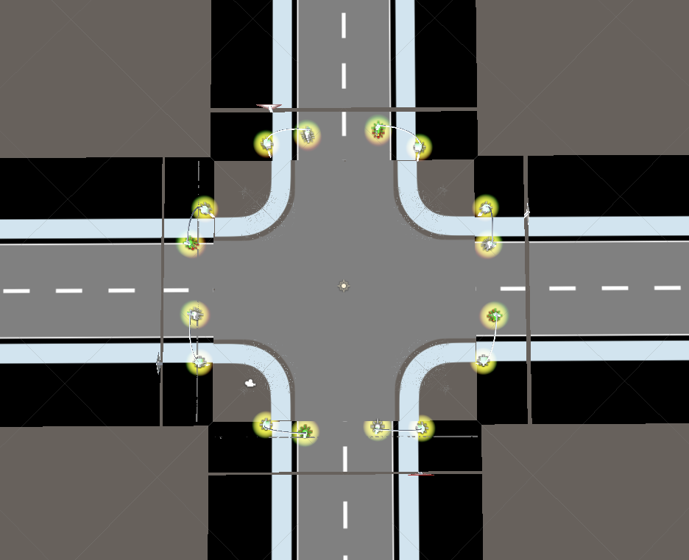

Figure 4.32 Layer Transparent

4.33 shown, the new problem appears. There are some gaps on the junction. It is because there are some gaps among different road section layers not

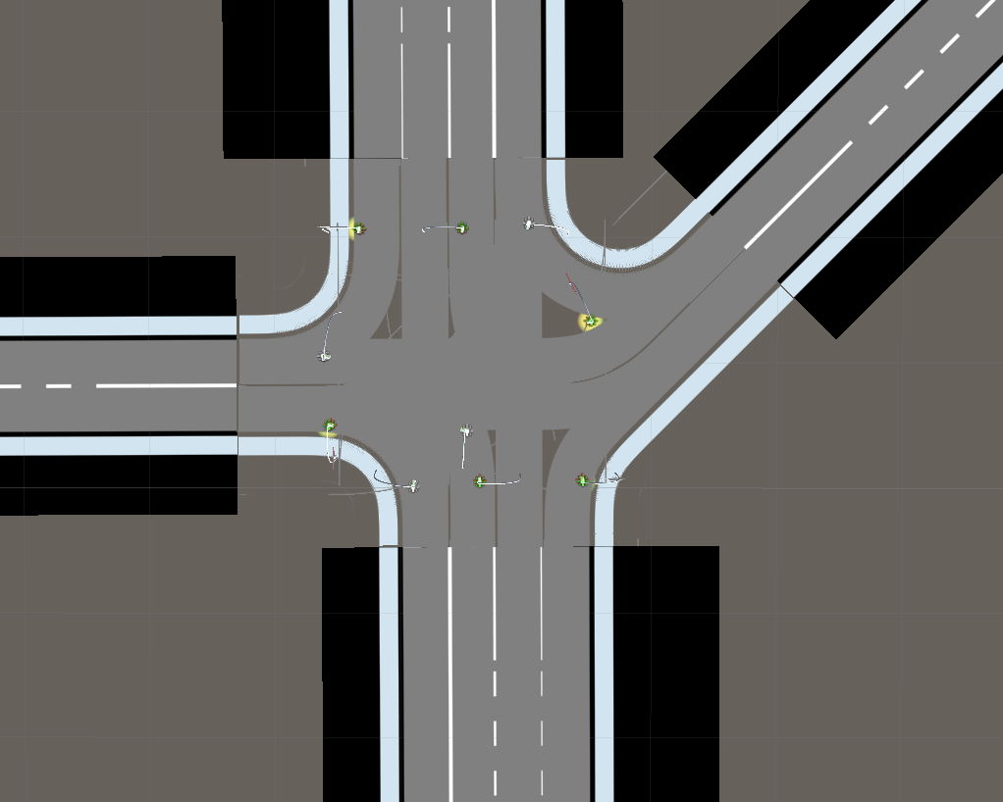

Figure 4.33 Gab Problem

belong to the lane when using the second solution, the area does not belong to the lane also turn to be transparent. Third solution is to create a new junction layer.

The way to create a new junction layer is illustrated following:

1. Get all vertexes of road sections as shown in figure 4.34 red points.
2. Using Gift Wrapping Algorithm to find the convex hull of these vertexes set in figure 4.34 yellow line.
3. According to the vertexes on the convex hull to create mesh in Unity3D as shown in figure 4.35.

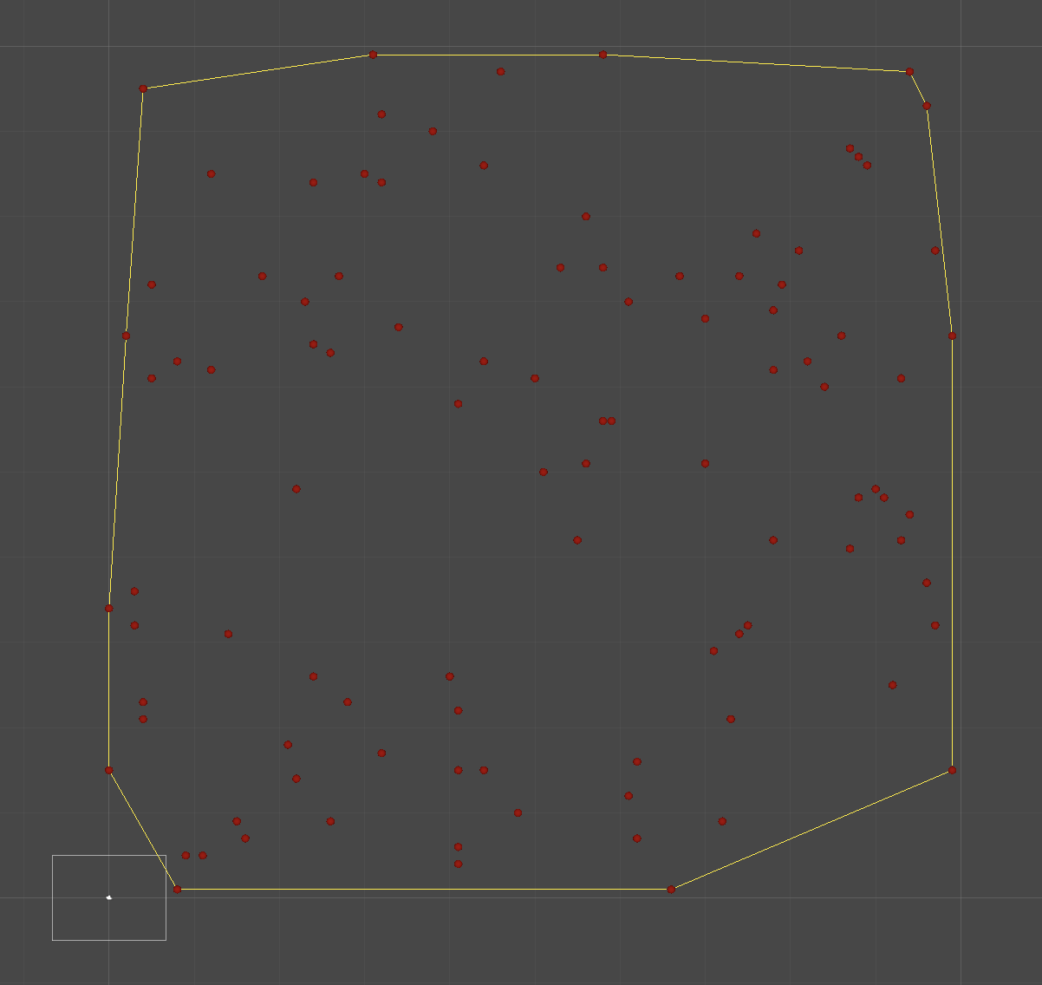

Figure 4.34 Convex Hull

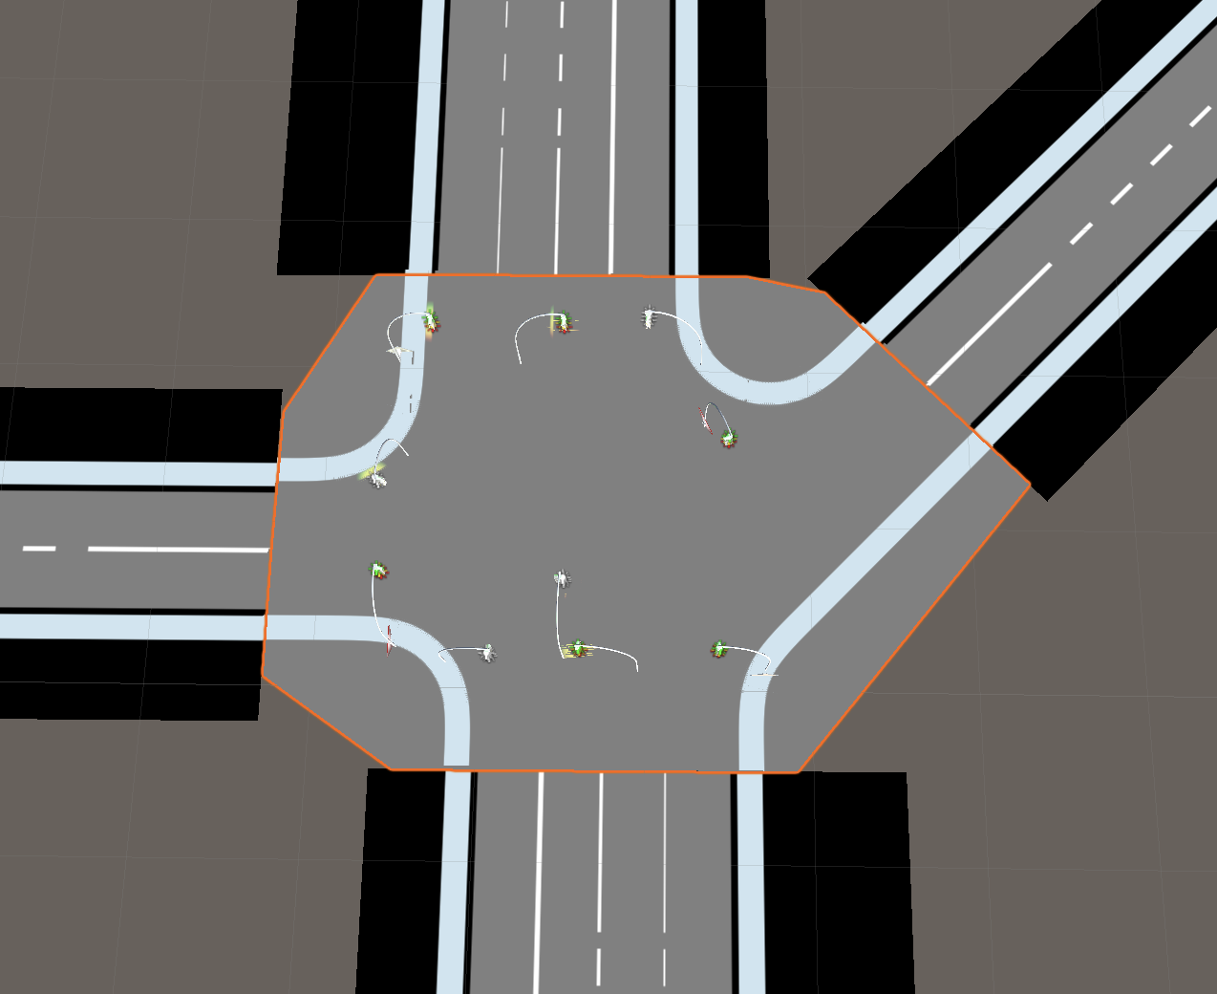

Figure 4.35 Junction Layer

Figure 4.34 red point is created by random, it is mainly to illustrate what is the convex hull (yellow line). As figure 4.35 shown, the gap on the junction (polygon with orange bound) disappeared.

5 Results And Discussion

In this chapter, will give a summary of the plugin and discuss some problems derive from developing the plugin.

5.1 Results

After testing all the data from the official website and compare the road network model which established by the program (see in appendix) with the official model [1], it is obvious that the algorithm of the program is correct, including the geometry of the road, lane, signals and the elevation of the road are all correctly created.

5.2 Discussion

In the OpenDRIVE the lane coordinate is a double format, but the plugin use the texture to draw the lane, the coordinate of texture is integer (pixel) format. So there is a small bias during transfer double to integer.

During decide the road width, use max left width and max right width. The main goal is to decrease the code complex. But it makes the road network not looks good. As the figure 5.3 shown.

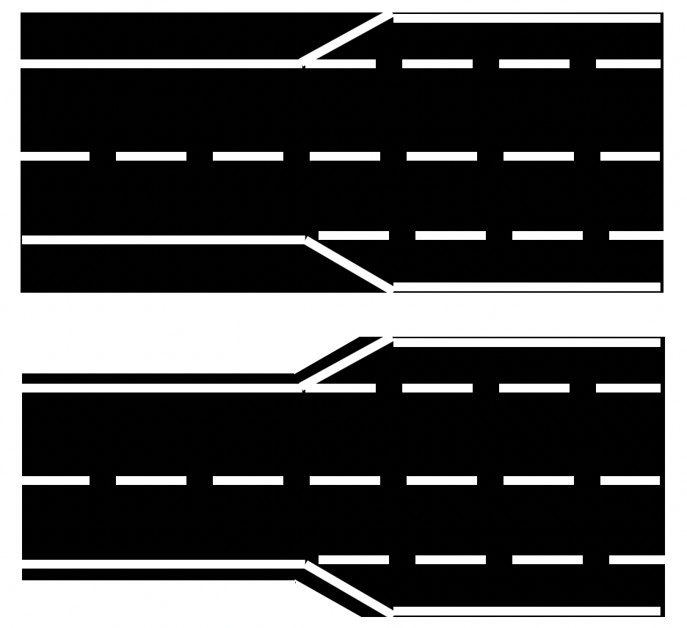

Figure 5.1: Dynamic Width

Obviously, the second figure looks better.

5.3 Outlook

Finally, everything looks good, but there are still some problems can be further improved.

Firstly though the plugin till now can only support limit record nodes in OpenDRIVE file, it is enough to support driving simulation, the thesis already establishes a frame and algorithm for the plugin which can easily add new node (e.g. railroad node record, object node record) in the plugin to make the road network more real.

Secondly, Unity3D only supports up to 65535 vertexes in a mesh, the plugin creates road mesh using 3 vertexes every 0.2 unit, it means that if a road section length over 109225 unit, the road section mesh will not appear. The solution is when the road is a straight line, try to use as fewer vertexes as possible. Theoretically, it only needs 6 vertexes to create the line road section mesh, no matter how long the line road section is. The solution is that add a judgment statement, increase $∆d$ (mentioned in figure 4.2 ) when the line road section is parsed.

Thirdly, as figure 5.1 discuss, to reduce code complexity, the plugin uses the maximum width as the width of the road section, actually, the width of the road section could change along the length. The solution is to store the correspondence between the absolute length and the width in different length.

Fourth, as chapter 4.3 illustrates, though there are already some solutions to deal with junction problem, there is still space to improve. The third solution of chapter 4.3 is using convex hull to create a new junction layer. But the new junction layer outbound is not precious, it will derive extra part in the junction. The best solution is to calculate the concave hull of the junction and create the junction layer. But after calculating the concave hull of the junction, a new problem derived, how to construct triangle in the concave hull? The solution is to use Delaunay triangulation to construct triangle in the concave hull and delete the line which out of concave hull black bound as figure 5.1 illustrate.

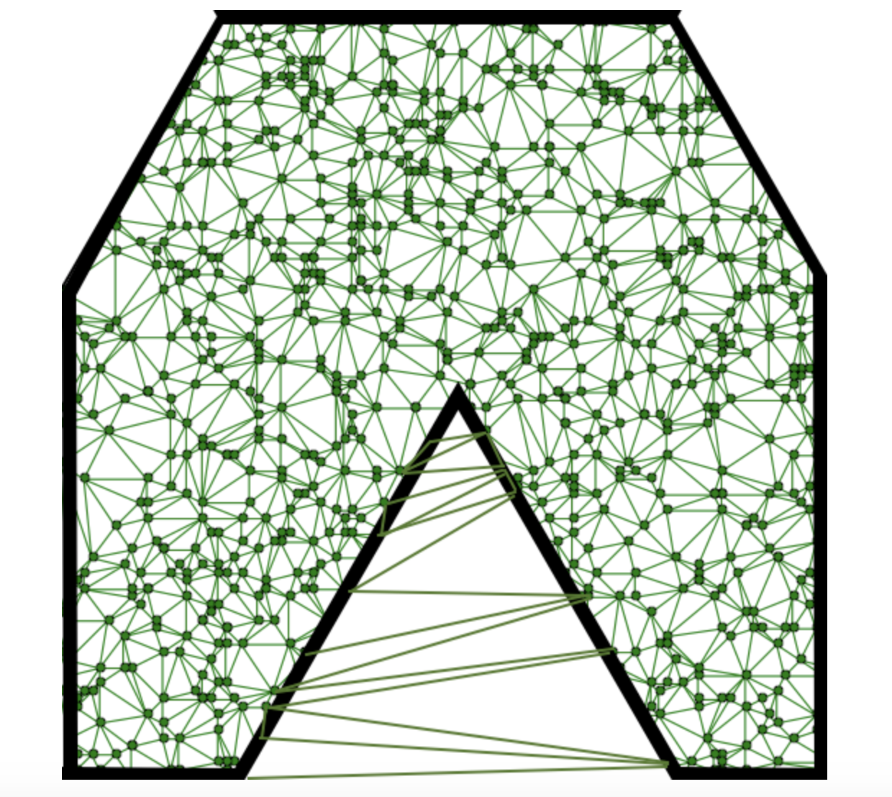

Figure 5.1 Delaunay Triangulation

Of course, there are already some libraries to help to implement automatic to create some triangles in a polygon e.g. Triangle.NET.

Bibliography

1. "OpenDRIVE - Home", *Opendrive.org*, 2019. [Online]. Available: http://www.opendrive.org/index.html. [Accessed: 11- Apr- 2019].
2. A. Barsi, V. Poto and V. Tihanyi, "Creating OpenCRG Road Surface Model from Terrestrial Laser Scanning Data for Autonomous Vehicles", 2019. .
3. *Opendrive.org*, 2019. [Online]. Available: http://opendrive.org/docs/OpenDRIVEFormatSpecRev1.5H.pdf. [Accessed: 11- Apr- 2019].
4. "opendrive roads | Add OpenDRIVE Roads to Driving Scenario - MATLAB &am", *Keywordniches.com*, 2019. [Online]. Available: http://www.keywordniches.com/search/opendrive-roads. [Accessed: 11- Apr- 2019].
5. I. Zamojc, "Introduction to Unity3D", *Code Envato Tuts+*, 2019. [Online]. Available: https://code.tutsplus.com/tutorials/introduction-to-unity3d--mobile-10752. [Accessed: 11- Apr- 2019].
6. "Unity (game engine)", *En.wikipedia.org*, 2019. [Online]. Available: https://en.wikipedia.org/wiki/Unity_(game_engine). [Accessed: 11- Apr- 2019].
7. 2019. [Online]. Available: https://www.merriam-webster.com/dictionary/simulator. [Accessed: 11- Apr- 2019].
8. "Learn C# in 7 days", *O’Reilly | Safari*, 2019. [Online]. Available: https://www.oreilly.com/library/view/learn-c-in/9781787287044/0b58f137-5542-4066-a516-00d18b8dcea7.xhtml. [Accessed: 11- Apr- 2019].
9. 2019. [Online]. Available: http://all-searches.com/recherche/Unity::2d::Guide/web/3. [Accessed: 11- Apr- 2019].
10. U. Technologies, "Unity - Manual: Textures", *Docs.unity3d.com*, 2019. [Online]. Available: https://docs.unity3d.com/Manual/Textures.html. [Accessed: 11- Apr- 2019].

Appendix

The following figures are created by the plugin according the data published on OpenDRIVE offical website and Chair of mechatronics.

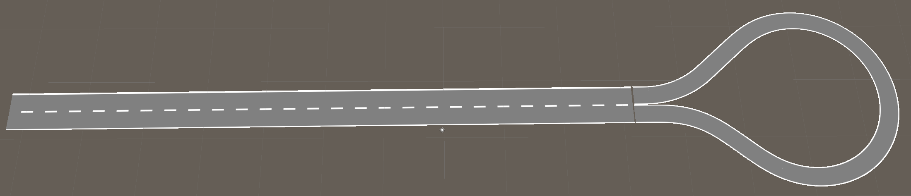

Figure A.1: Sample Of Dead-end Road

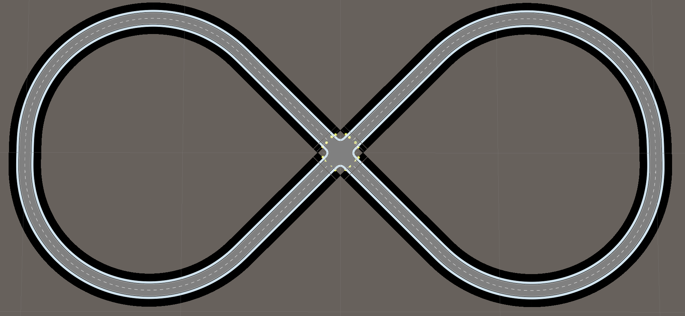

Figure A.2: Sample Of a Atandard Crossing With Traffic Lights

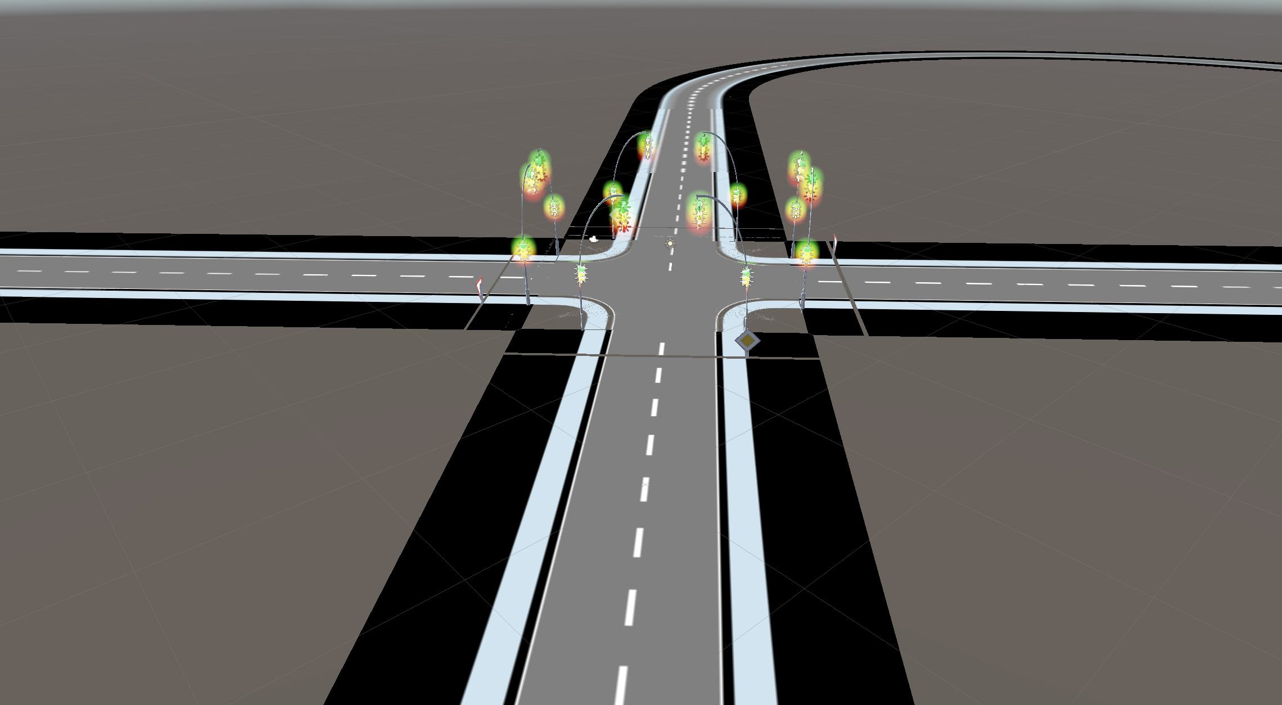

Figure A.3: Sample Of a Standard Crossing With Traffic Lights

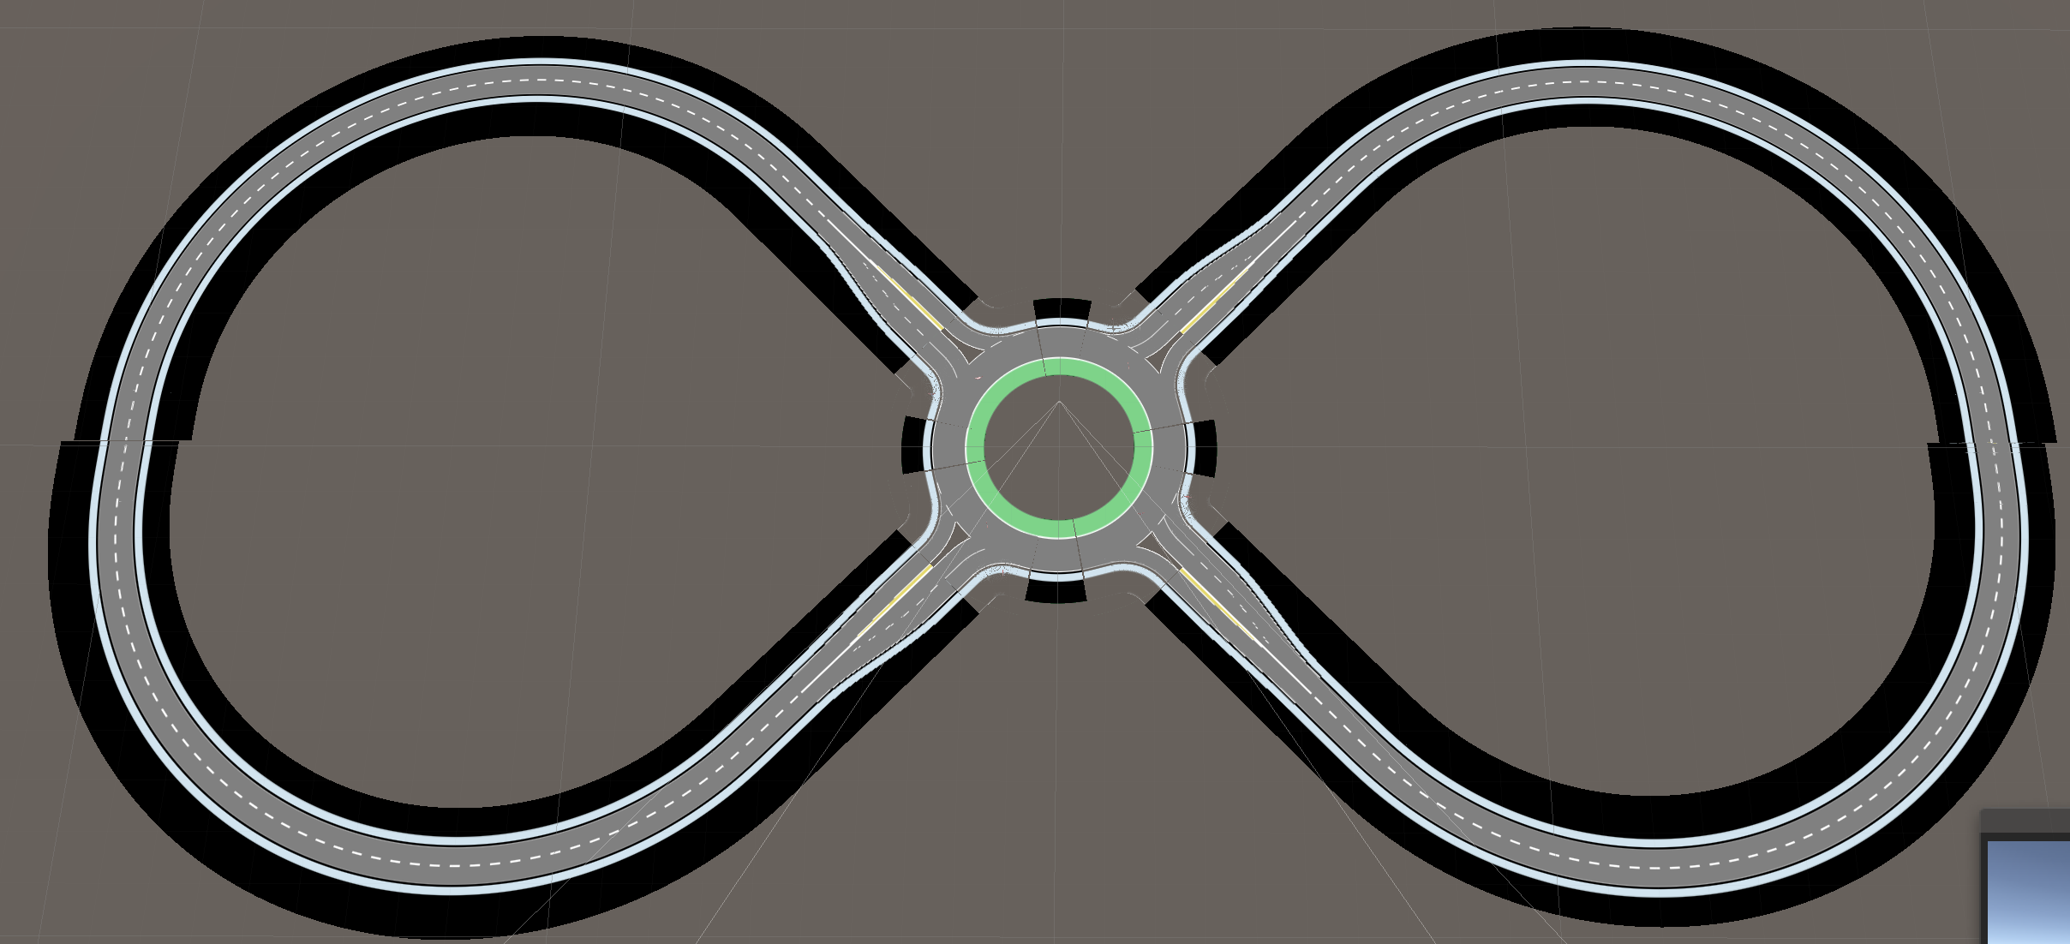

Figure A.4: Sample Of a Roundabout

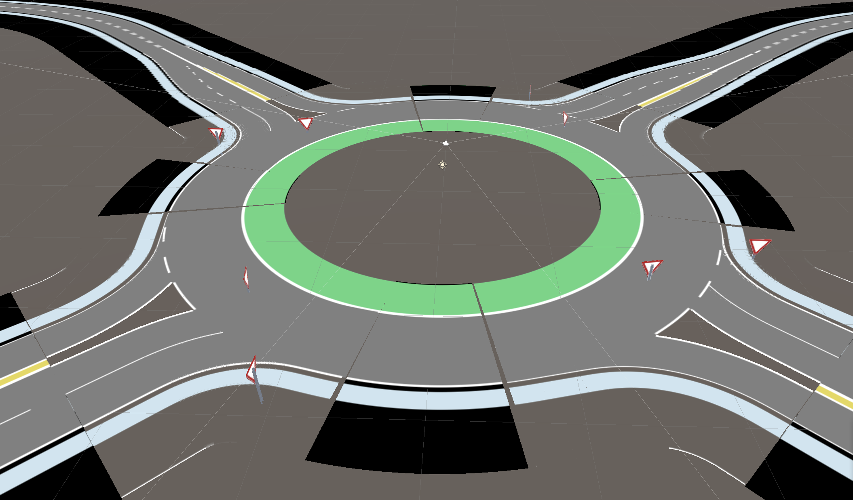

Figure A.5: Sample Of a Roundabout

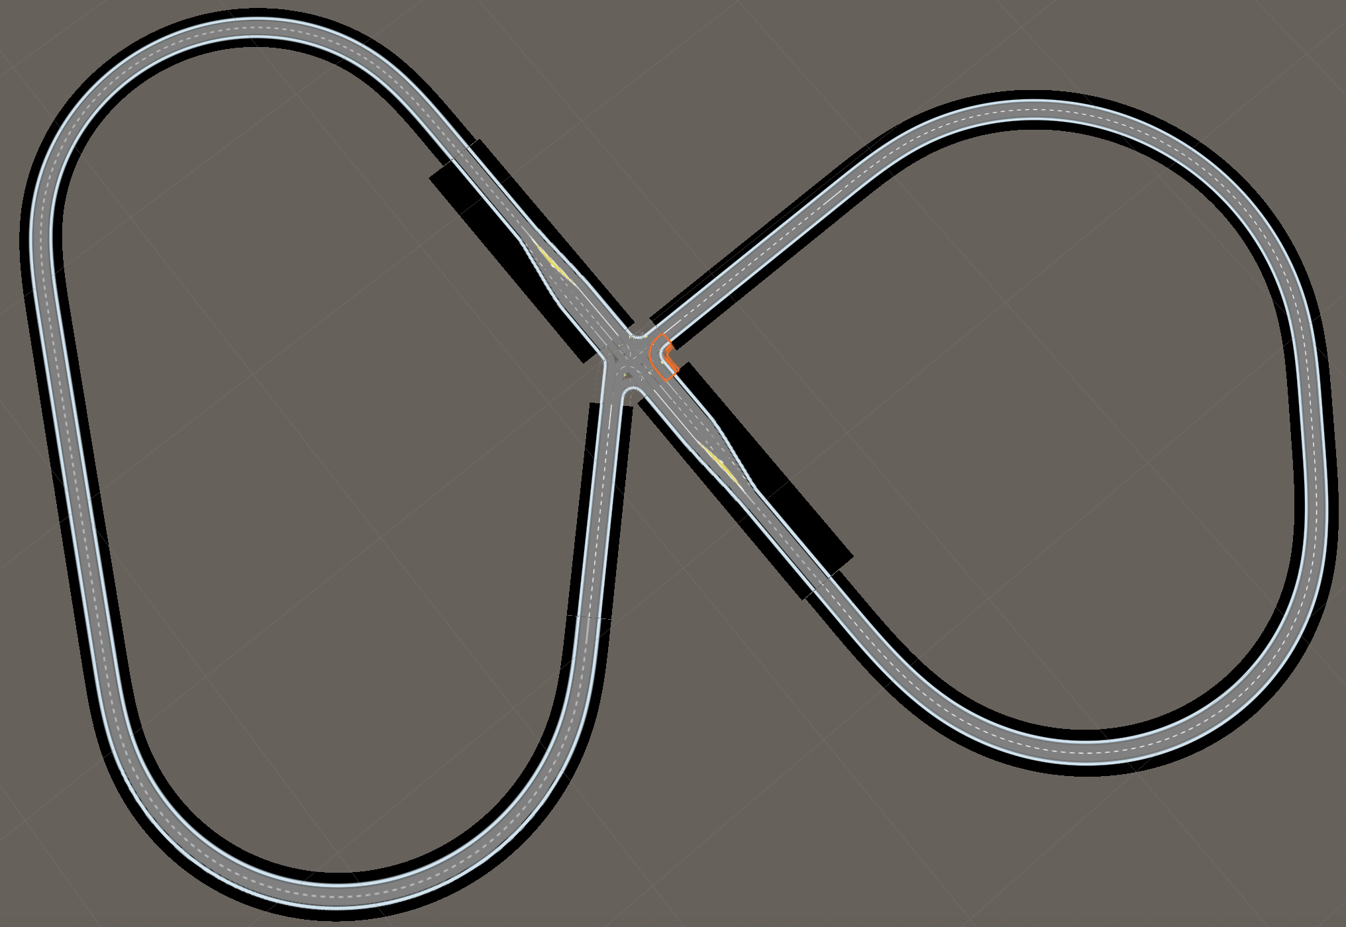

Figure A.6: Sample Of a Complex Crossing With Traffic Lights

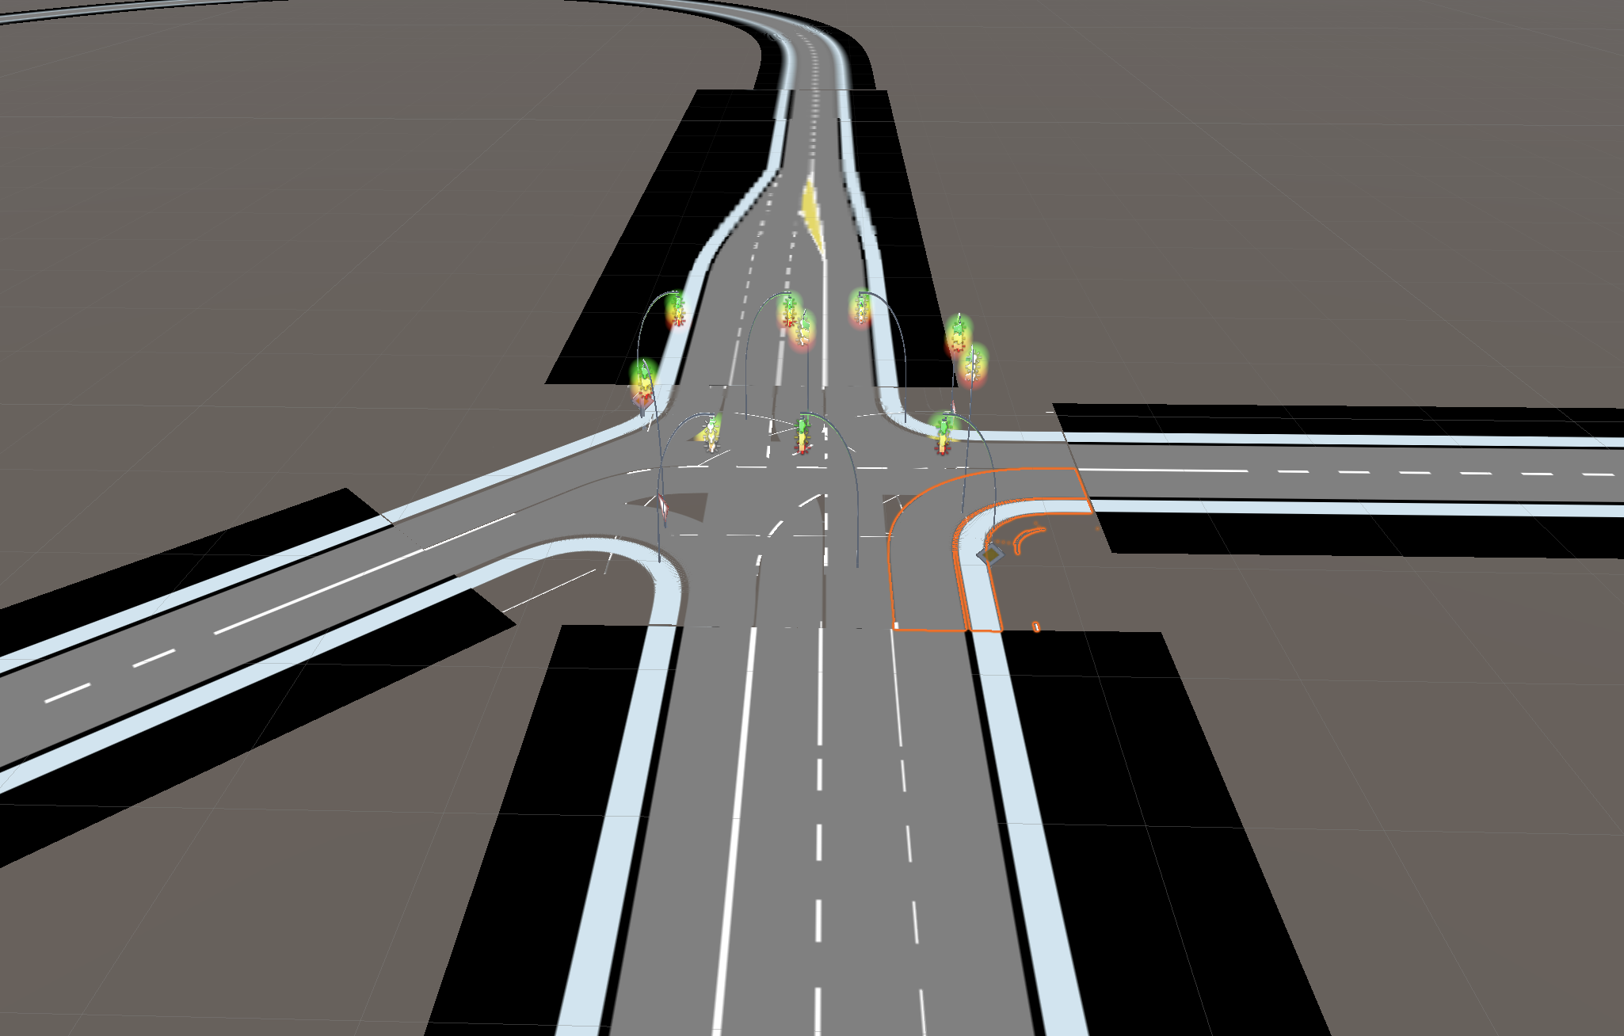

Figure A.7: Sample Of a Complex Crossing With Traffic Lights

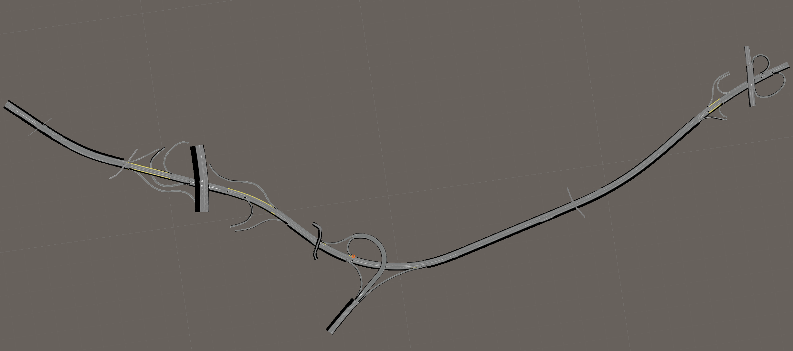

Figure A.8: Sample By Atlatec

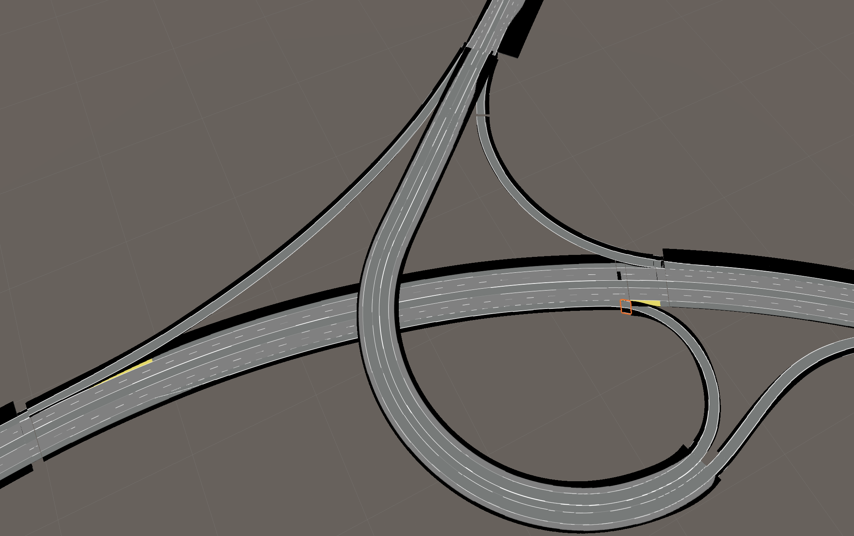

Figure A.9: Sample By Atlatec

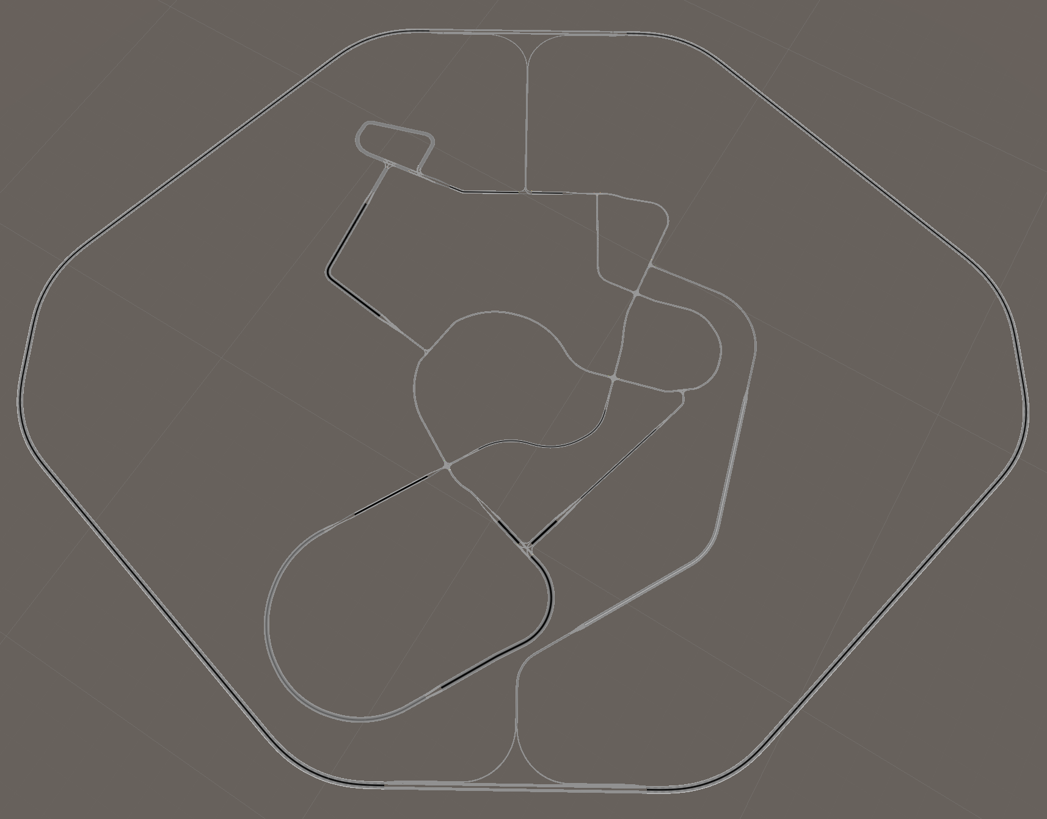

Figure A.10: Sample By Chair Of Mechatronics

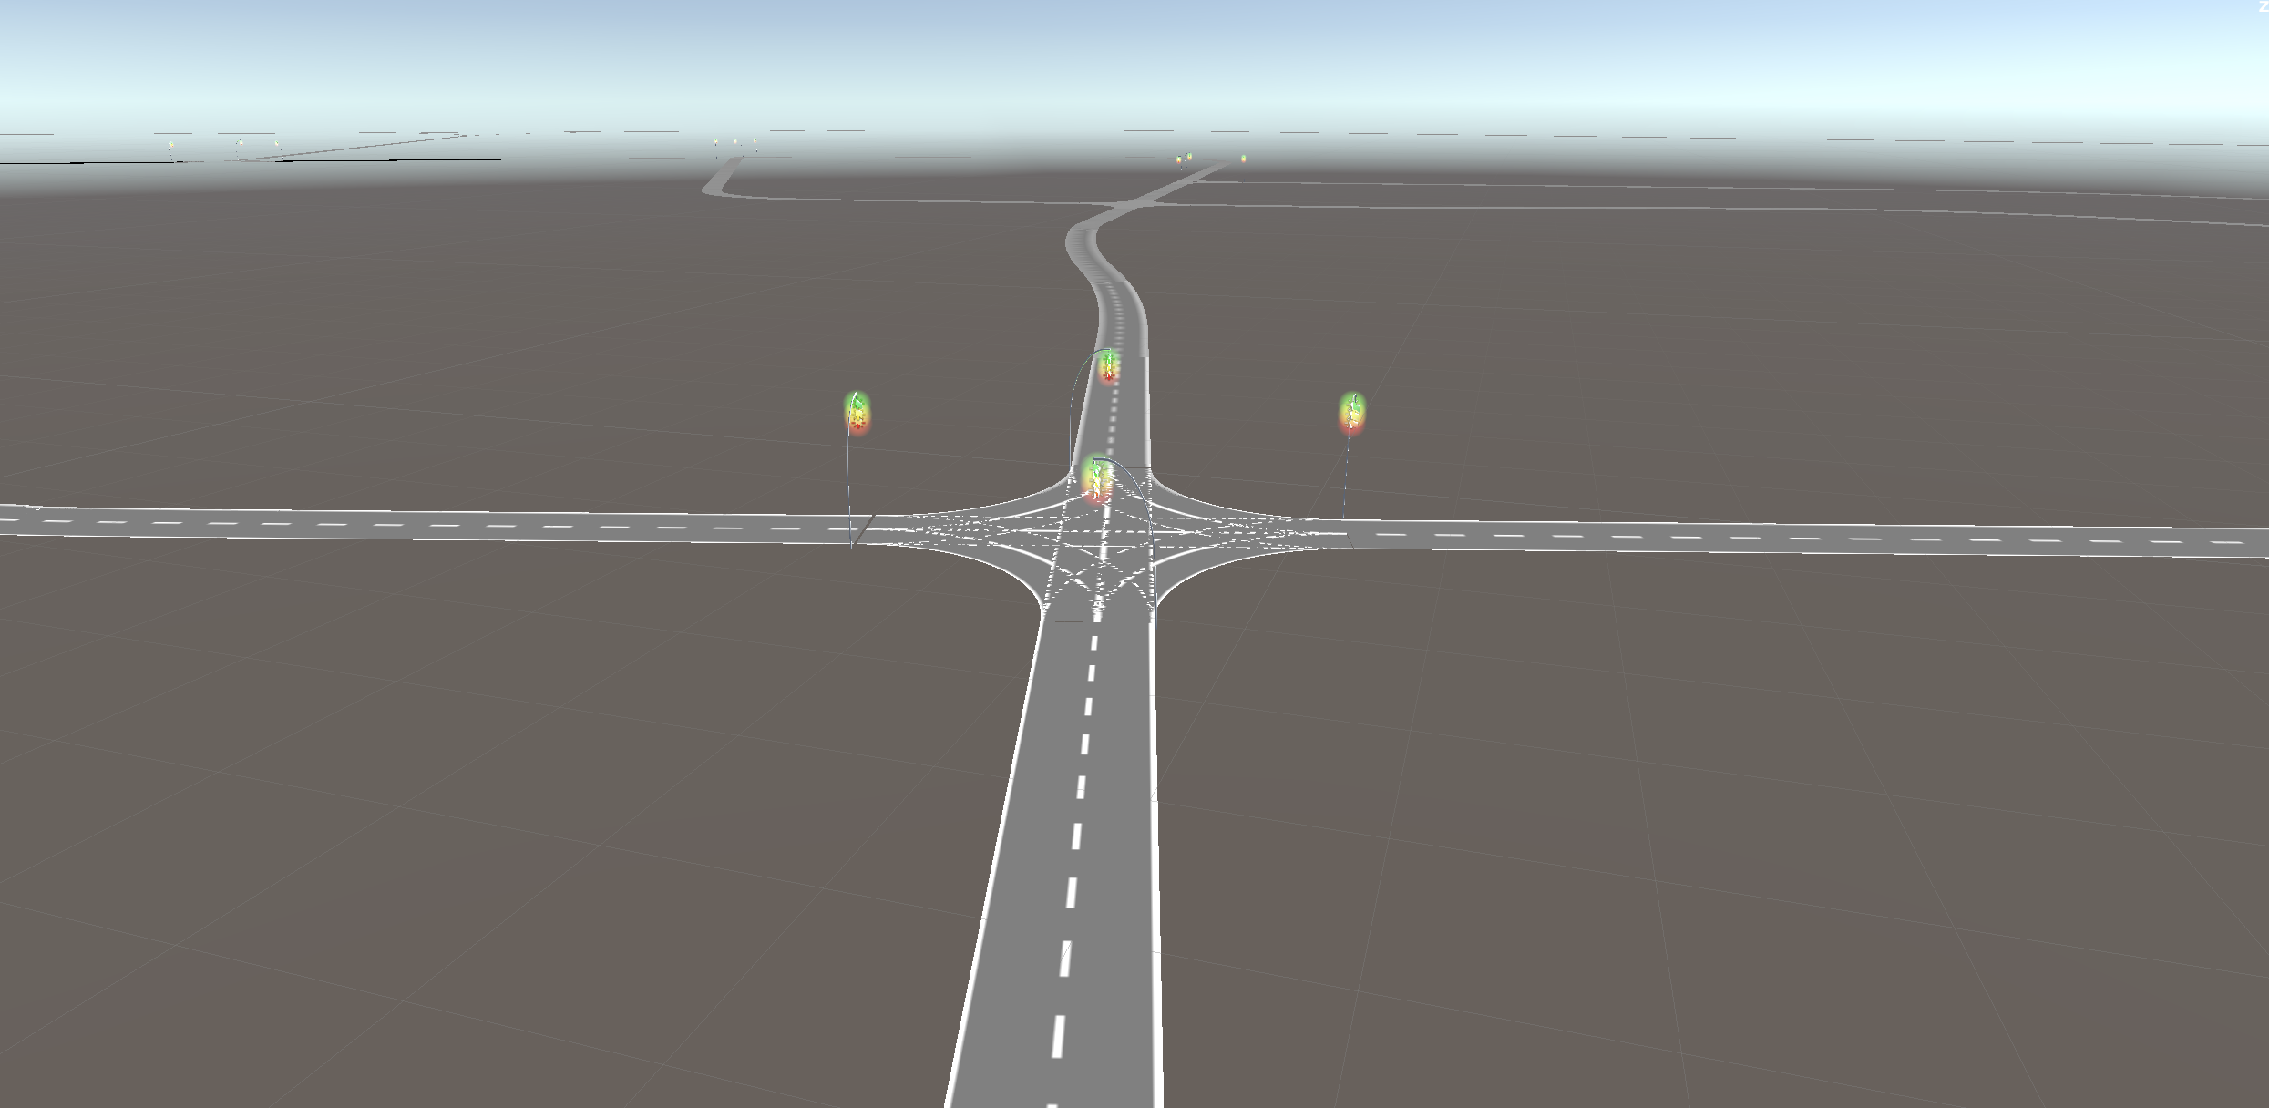

Figure A.11: Sample By Chair Of Mechatronics